**IOT BASED SMART AGRICULTURE MONITORING SYSTEM**

**A Project Report**

*Submitted By*

# ANUSHA K K (KTE17EE018)

# *to*

**APJ ABDUL KALAM TECHNOLOGICAL UNIVERSITY**

*in partial fulfillment for the award of the degree*

**BACHELOR OF TECHNOLOGY**

*in*

**ELECTRICAL AND ELECTRONICS ENGINEERING**

**DEPARTMENT OF ELECTRICAL & ELECTRONICS ENGINEERING**

# RAJIV GANDHI INSTITUTE OF TECHNOLOGY KOTTAYAM

**VELLOOR - 68650**

**JUNE 2022**

# DEPARTMENT OF ELECTRICAL ENGINEERING

# RAJIV GANDHI INSTITUTE OF TECHNOLOGY KOTTAYAM

**VELLOOR, KOTTAYAM - 686501**

**www.rit.ac.in**



**CERTIFICATE**

# *This is to certify that this project report entitled “IOT BASED SMART AGRICULTURE MONITORING SYSTEM” is a bonafide record of the project presented by Ms. ANUSHA K K (KTE17EE018) to APJ Abdul Kalam Technological University in partial fulfillment of the requirements for the award of Degree of Bachelor of Technology in Electrical & Electronics Engineering, is a bonafide record of the Project carried out by her under our guidance and supervision. This report in any form has not been submitted to any other University or Institute for any purpose.*

**Prof. Neeba Sabu** **Prof. Peter K Abraham** **Dr. Johnson Mathew**

Project Guide Project Coordinator Head of the Department

**ACKNOWLEDGEMENT**

The contentment and euphoria that accompany the successful completion of any task would not be complete without the mention of people who have helped to make it possible. First and foremost, I thank God Almighty for his abundant blessings without which I would not be able to complete this project.

I sincerely thank *Dr. C Sathish Kumar.*, the Principal of Rajiv Gandhi Institute of Technology, Kottayam and *Dr. Johnson Mathew*, the Head of the Department of Electrical Engineering, for providing me with the best facilities and atmosphere for the completion of my project.

I am indebted to our guide *Prof.* *Neeba Sabu*, Assistant Professor, project guide as well as our project coordinator *Dr. Peter K Abraham*, Associate Professor of Electrical Engineering Department who continually and convincingly conveyed a spirit of adventure in regard to my final year project and excitement in the goodwill to conduct the study. I also take this opportunity to thank all other staff members of the Electrical Department for their help and support.

I am especially grateful to my classmates for their assistance, criticisms and useful insights. Finally, this project would have not been possible without the confidence, endurance and support of my family. My family has always been a source of inspiration and acknowledgement.

RIT, Kottayam ANUSHA K K

June 2022

**ABSTRACT**

Agriculture is undoubtedly the largest livelihood source in India, the backbone of the country's economy and provides to the total economic growth of India. Agriculture is constrained every year by challenges, such as Climate Changes and Population Growth. Matters concerning agriculture have been always hampering the advancement of the country. A revolution in agriculture is expected and the IoT Based Smart Agriculture Robotic System is a part of it. Internet of Things (IoT) sensors have capability of providing meaningful information for agriculture making this concept more emerging and attractive day by day. In this project, we designed a system using smart technology which can do complex work easily. This work meets major factors of agriculture, field monitoring, and automated systems. The system designed in this project can monitor the humidity, soil moisture level, temperature and amount of sunlight. According to the data received from all the sensors, the water pump and exhaust fan get automatically activated or deactivated. This project not only focuses on the crop field but also stores the data in cloud using IoT for further analysis for doing precise agriculture. Using those data, forecasts can be made about future events. In this project , IoT is controlled by the mobile application, which can be operated from anywhere. Automation systems work based on sensors and actuators. Using this system, farmers will be able to do efficient work and can ensure crop productivity will be at its highest level. Smart Agriculture Robot using IoT can have a positive effect on today's agricultural growth.

**CONTENTS**

|  |  |
| --- | --- |
| **ACKNOWLEDGEMENT** | i |
| **ABSTRACT** | ii |
| **LIST OF FIGURES** | viii |
| **LIST OF TABLES** | ix |
| **ABBREVIATIONS** | x |
| **NOTATIONS** | xi |
| **1. INTRODUCTION** | 1 |
| 1.1 Overview | 2 |
| 1.2 Project Background | 2 |
| 1.3 Problem Statements | 2 |
| 1.4 Project Objectives | 3 |
| **2. LITERATURE REVIEW** | 4 |
| 2.1 Overview | 4 |
| 2.2 Smart Farming | 4 |
| 2.3 Internet Of ThingsIOT) | 4 |
| 2.4 Wireless Sensor Network(WSN) | 5 |
| 2.4.1 Applications of WSN | 6 |
| 2.4.2 Soil Moisture Sensor | 6 |
| 2.4.3 Temperature and Humidity Sensor | 7 |
| 2.4.4 Light Sensor | 8 |
| 2.5 Motor Controllers | 9 |
| 2.5.1 Direction Controller-H Bridge | 10 |
| 2.5.2 Speed Controller-PWM | 11 |
| 2.5.3 Applications of Motor Controllers | 11 |
| 2.6 Servo Motors | 11 |
| 2.6.1 Servo Motor Working Principle | 12 |
| 2.6.2 Controlling Servo Motor | 13 |
| 2.7 WIFI Development Boards | 13 |
| 2.7.1 ESP32 | 14 |
| 2.7.2 ESP8266 | 14 |
| 2.8 Gear Motors | 16 |
| 2.8.1 Diagram of Gear Motor | 16 |
| 2.8.2 Applications of Gear Motor | 17 |
| 2.9 ESP32 CAM Board | 17 |
| 2.9.1 Features of ESP32 CAM Board | 17 |
| 2.10 3D Printing | 17 |
| 2.11 Blynk Interface | 18 |
| 2.12 Battery | 19 |
| 2.13 Voltage Regulator | 19 |
| **3. FIELD MONITORING ROBOT AND ON FIELD CONTROL** | 21 |
| **UNIT** |  |
| 3.1 Overview | 21 |
| 3.2 Basic Principle of Agriculture Monitoring Robot | 21 |
| 3.3 Block Diagram | 22 |
| 3.3.1 ESP2 Module | 22 |
| 3.3.2 Moisture Sensor | 22 |
| 3.3.3 Temperature and Humidity sensor | 22 |
| 3.3.4 Light Sensor | 22 |
| 3.3.5 Camera Module | 22 |
| 3.3.6 Motor Driver | 22 |
| 3.3.7 Gear Motors | 23 |
| 3.3.8 Servo Motors | 23 |
| 3.4 Functions Performed by the Robot | 23 |
| 3.5 Basic Principle of ON-Field Controlling Unit | 23 |
| 3.6 Block Diagram of ON-Field Control Unit | 24 |
| 3.6.1 ESP8266 Module | 24 |
| 3.6.2 Water Pump | 24 |
| 3.6.3 Exhaust Fan | 24 |
| **4. SELECTION AND DESIGN OF COMPONENTS** | 25 |
| 4.1 Overview | 25 |
| 4.2 Component Selection and Design | 25 |
| 4.2.1 DC Geared Motor | 25 |
| 4.2.2 Battery sizing | 26 |
| 4.2.3 BH1750 | 27 |
| 4.2.4 DHT22 | 27 |
| 4.2.5 XH-M214 | 28 |
| 4.2.6 L298N Driver | 28 |
| 4.2.7 ESP32 | 29 |
| 4.2.8 ESP8266 | 30 |
| 4.2.9 ESP CAM Board | 30 |
| 4.2.10 SG90 Servo | 31 |
| 4.2.11 MG995 Servo | 32 |
| 4.3 Software Selection | 33 |
| 4.3.1 Proteus | 33 |
| 4.3.2 Arduino IDE | 34 |
| 4.3.3 Easy EDA | 34 |
| 4.4 Cost Estimation | 35 |
| **5. SIMULATION STUDIES AND FLOWCHARTS** | 37 |
| 5.1 Chapter Overview | 36 |
| 5.2 Simulation of Sensors and Motor Driver | 37 |
| 5.3 Test Results of DHT22 and DHT11 | 38 |
| 5.3 Test Results of Light Sensor | 38 |
| 5.4 Flowchart of Field Monitoring Robot | 39 |
| 5.5 Flowchart of Robotic arm | 40 |
| **6. HARDWARE IMPLEMENTATION AND OUTPUTS** | 41 |
| 6.1 Overview | 41 |
| 6.2 Battery | 41 |
| 6.3 Voltage Regulator | 41 |
| 6.4 Power Supply | 41 |
| 6.5 PCB Designing | 41 |
| 6.5.1 Introduction | 42 |
| 6.5.2 PCB Construction | 42 |
| 6.5.3 Equipments Required | 42 |
| 6.5.4 Precautions for practical | 42 |
| 6.6 Circuit Diagram | 43 |
| 6.7 Results and Outputs | 44 |
| 6.8 BLYNK Interface | 45 |
| 6.9 Path Planning | 46 |
| **7. CROP SELECTION AND CONTROL OF FARM** | 47 |
| **PARAMETERS** |  |
| 7.1Selection of Crops | 47 |
| 7.2Irrigation Control | 48 |
| 7.3Exhaust Control | 49 |
| **8. CONCLUSIONS** | 50 |
| **9. SCOPE FOR FUTURE** | 51 |
| **REFERENCES** | 53 |
| **APPENDIX I** | 55 |
| **APPENDIX II** | 56 |
| **APPENDIX III** | 70 |

**LIST OF FIGURES**

|  |  |  |
| --- | --- | --- |
| I | General Structure of Wireless Sensor Network | 5 |
| II | Internal Circuit Diagram of Soil Moisture Sensor | 7 |
| III | Connection Diagram of DHT22 | 8 |
| IV | Block Diagram of Light Sensor | 9 |
| V | Block Diagram of Motor Controller | 10 |
| VI | Schematic of Servo motor | 12 |
| VII | Position Control of Servo Motor Using PWM | 13 |
| VIII | Internal Architecture of ESP32 | 14 |
| IX | Internal Architecture of ESP8266 | 15 |
| X | Mechanism of gear motor | 16 |
| XI | Block Diagram of IC based voltage regulator | 20 |
| XII | Block Diagram of Robot | 22 |
| XIII | Block Diagram of On Field Control Unit | 24 |
| XIV | 3D Model of Robotic Arm | 33 |
| XV | Simulation of Sensors and Motor driver | 37 |
| XVI | Voltage Regulator | 41 |
| XVII | Circuit Diagram of Project | 43 |
| XVIII | Blynk Interface | 45 |

**LIST OF TABLES**

|  |  |  |  |
| --- | --- | --- | --- |
| I | Technical Specifications of BH1750 | 27 |  |
| II | Technical Specifications of DHT22 | 28 |  |
| III | Technical Specifications of XH-M214 | 28 |  |
| IV | Technical Specifications of L298N DRIVER | 29 |  |
| V | Technical Specifications of ESP32 | 29 |  |
| VI | Technical Specifications of ESP8266 | 30 |  |
| VII | Technical Specifications of ESP32Cam Board | 30 |  |
| VIII | Technical Specifications of SG90 Servo | 31 |  |
| IX | Technical Specifications of MG995 Servo | 32 |  |
| X | Cost Estimation | 35 |  |
| XI | Results and Output- Trial 1 | 44 |  |
| XII | Results and Output- Trial 2 | 44 |  |
| XIII | Selection of Crops | 47 |  |
| XIV | Irrigation Control | 48 |  |
| XV | Exhaust Control | 49 |  |
|  |  |  |  |
|  |  |  |  |
|  |  |  |  |

**ABBREVIATIONS**

SAS Smart agriculture Systems

IoT Internet of Things

PWM Pulse Width Modulation

IDE Integrated Development Environment

DC Direct Current

SPI Serial Peripheral Interface

UART Universal asynchronous receiver Transmitter

SoC System on Chip

GPIO General Purpose Input/Output

FTDI Future Technology Devices International Limited

PCB Printed Circuit Board

GPS Global Positioning System

IDE Integrated Development Environment

WSN Wireless Sensor Network

**NOTATIONS**

μs  Friction Coefficient

V Desired Velocity

r Wheel radius

ω Angular Velocity

Ff Frictional force

Wsystem Weight of the System

Msystem Mass of the system

amax Maximum Acceleration

Ah Ampere-Hour

Mwheel Mass of the wheel

Tmax Maximum Torque

**CHAPTER 1**

**INTRODUCTION**

Agriculture is one amongst the fundamental sources of keep for folks and plays a key role within the development of the agricultural economy.Smart Agriculture is becoming a very important essence for farmers nowadays and it will become more important in the upcoming era for proper growth of the fields and increase in the productivity of yields.With the increasing demand for food, good agriculture and farming applications have gained importance and wide usage because the ancient ways have lost their efficiency.The ancient agriculture production lacks the appliance of the knowledge and technology that has been widely utilized in business, and different aspects of life.The immediate actions are to be taken to save the excess amount of water, need of fertilizers,extreme temperature and light etc.Smart Agriculture Systems (SAS) are driven by several key factors, which include the adoption of IoT technologies for remote, unmanned monitoring of the agriculture fields and taking corrective actions to make the environment most conducive for crop growth [7].SAS depends on a combination of hardware and software technologies for optimum benefits. IoT is an integration of multiple devices which communicate, sense and interact with their internal and external states through the embedded technology that IoT contain.By employing the foremost recent sensing and IoT technologies in cultivation methods, all the aspects of traditional farming methods are often fundamentally changed. It is also the solution of many farming issues, like a flood, drought response, crop optimization, soil suitability, irrigation, and harvesting. The integration of automation system, sensors and the IoT in smart agriculture can raise farming to levels that were previously unimaginable.To automate the farming operations, several environmental parameters those have impact on farming, are required to track down at different locations. The important environmental parameters include temperature, moisture, and water level [2]. Different types of sensors are deployed over the field to monitor those environmental parameters related to farming and attached with microcontroller. According to environmental condition, microcontroller controls different actuators or farming equipment (Pump, Fan etc.) without human intervention. Apart from that these sensed data can be stored in the cloud. Microcontroller attached with wi-fi module sends those sensed parameters to the cloud The fundamental objective of smart agriculture using IoT with automation system and robotics is to improve productivity by improving irrigation facilities of the crop field, harvesting, cutting weeds which will generate better revenues for the farmers and build a strong economy.

**1.1 OVERVIEW**

This chapter discusses the use of modern technology in agriculture practices is expanding rapidly. Automation is increasing productivity and decreasing physical work. The methods which are used in the agriculture system of our country are more manual rather than automatic. In our project, there is a robotic vehicle having four-wheels which uses high torque DC gear motors and the axle and chassis of the car are built as an off-road vehicle. Cultivation and irrigation will be done based on the monitored parameters.

**1.2 PROJECT BACKGROUND**

Farmers in our country still use manual techniques for cultivation, monitoring, irrigating, etc. This shows that we badly need smart automation to enhance the productivity of farming which in turn will give us better revenues as well as food problem solutions for the country. When it comes to environmental problems, smart agriculture using IoT provides us with multiple advantages including efficient use of natural resources like water and soil. IoT helps agriculture in precision farming using data through the internet. Smart Agriculture Robotic system is a method to make the procedure of farming more precise and accurate. The key components used for Smart Agriculture Robotic system in farming are automated hardware, various sensors, and robotic vehicles [1]. The earliest experts in agricultural sectors were skilled chemists who applied their talents to food production. Development of farming rules were not applicable in many rustic areas. Thus, there was an initial reliability trouble with the earlier agricultural research. The idea of an experiment station was first established in Europe during the mid-1800s. Scientists, Researchers and Engineers around the world are performing in creating and developing different tools, methods to do smart farming and automation systems in agriculture practices in recent times. There are many articles and publications that emphasize the role of Robotics, Internet of Things in the agriculture industry, but nearly all of them concentrated only on applications and did not provide any insightful results. Their focus was on the various IoT based designs, advanced models, and improved devices.

**1.3 PROBLEM STATEMENT**

Traditional irrigation requires excessive amounts of water and consumes high electrical energy to schedule irrigations. Nearly 60% of water used for irrigation is wasted. The major challenge in quality farming is unpredictable weather and environmental conditions such as rainfall, temperature, soil moisture etc. Moreover, humidity is one of the major environmental parameters in farming as it affects the turgor pressure of plants, which is an indicator of the amount of water in plant cells. When the amount of humidity in air is low, transpiration takes place very quickly in plants. Further, due to high rate of transpiration, plants wilt rapidly as too much water is pulled out from plant cells. On the contrary, when the amount of moisture in air as well as temperature is high, the rate of transpiration is reduced which in turn restricts evaporative cooling. In order to monitor these environmental conditions and action have been taken accordingly, continuous manual effort was required which is quite impractical and not possible all the time. Labour charges and time is expended for frequent visits and monitoring of farm areas. Unfavourable environment conditions can also severely affect the crop growth and yield. Undesirable values of temperature and humidity inside the greenhouse can hamper the growth and life cycle of the crops. Also early identification of diseases, pests and other abnormalities related to farms or crops is very essential for timely interference.

**1.4 PROJECT OBJECTIVES**

This project mainly aims for the following.

* To design and implement a robotic car for agriculture field monitoring.
* To provide the user or farmer with various parameters associated with greenhouse such as the soil moisture, temperature, humidity and sunlight,
* Incorporation of automatic irrigation and exhaust control system for maintaining optimum conditions for crops.
* To provide live streaming of farm areas for timely monitoring.
* To minimize the use of water and electrical energy required for farm processes.
* To provide manual operation of the irrigation system and exhaust fan.
* To implement path planning for the robot to enable easy maneuvering within the farm.

**CHAPTER 2**

**LITERATURE REVIEW**

**2.1 OVERVIEW**

For the implementation of this project, studies were conducted on the prospect of the IoT Based Intelligent Agriculture Field Monitoring System from sources including journals, IEEE papers, books, articles and others. A detailed explanation of topics relevant for this project are provided below.

**2.2 SMART FARMING**

Smart farming is the advancement of precision farming. The focus of precision farming was mainly on technological invention to allow for site-specific farming. Smart farm is about empowering today's farmers with the decision tools and automation measurement technologies that integrate products, knowledge and services for better productivity, quality and profit. The most important things of smart farming are environmental measurements and water management. The reason is that environmental and water management affects plant growth. In addition, environmental measurements using wireless sensor networks and water management technology are much simpler, cheaper and lower running costs [4].

**2.3 INTERNET OF THINGS - IOT**

The Internet of Things (IoT) is one of the emerging technologies that promise to transform the way people work and live. The term IoT refers to a network of physical objects ‘‘things’’ that contain embedded systems with connectivity and computing power to exchange data with other devices and systems over the Internet. IoT has become an ideal choice for smart agriculture due to its highly scalable and ubiquitous architecture. Smart agriculture has started incorporating IoT solutions to improve operational efficiency, maximize yield, and minimize wastage through real-time field data collection, data analysis, and deployment of control mechanisms.Also, the diverse IoT-based applications such as precision farming and smart irrigation are very helpful to the enhancement of agricultural processes. Thus, the IoT is considered as one of the promising solutions for embracing connected farms to address agriculture-based issues and increase the quality and quantity of agricultural production [11].

**2.4 WIRELESS SENSOR NETWORK**

Wireless Sensor Network (WSN) is an infrastructure-less wireless network that is deployed in a large number of wireless sensors in an ad-hoc manner that is used to monitor the system, physical or environmental conditions. Sensor nodes are used in WSN with the onboard processor that manages and monitors the environment in a particular area. They are connected to the Base Station which acts as a processing unit in the WSN System. Base Station in a WSN System is connected through the Internet to share data. They collects data through wireless channels and report over the Internet [10]. Networks of spatially dispersed and dedicated sensors that monitor and record the physical conditions of the environment and forward the collected data to a central location. WSNs can measure environmental conditions such as temperature, sound, pollution levels, humidity and wind.The general structure of a wireless sensor node is depicted in Fig. 2.1.

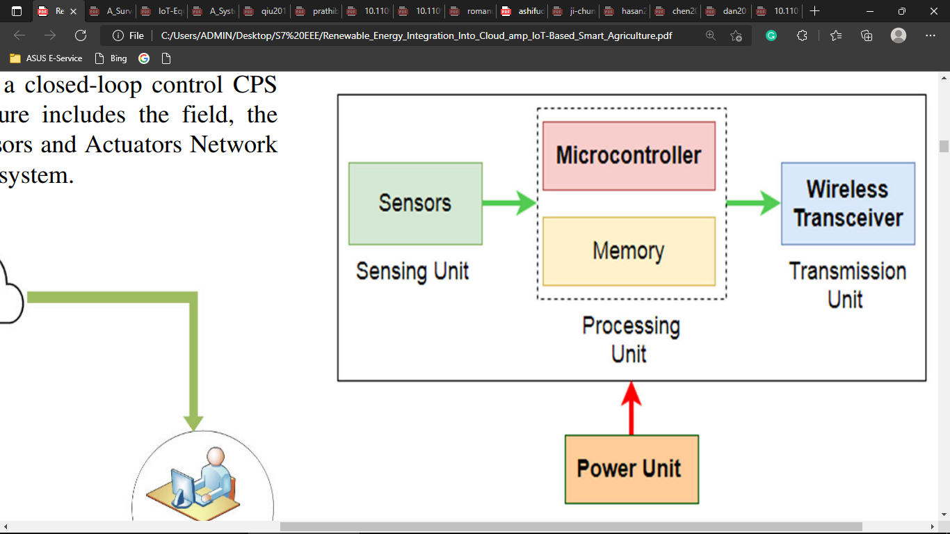

***Fig 2.1 General structure of a wireless sensor*.**

* The Sensing Unit consists of sensor modules that sample the environmental conditions of the deployment field.
* The Processing Unit consists of a microcontroller with a CPU and memory to run code and process the data.
* The Transmission Unit: This unit modulates digital data and sends it wirelessly. Several wireless technologies are adopted for this unit. In our deployment, we are using WIFI technology.
* The power Supply Unit is the Lithium-ion (Li-ion) battery that powers the wireless sensor node

**2.4.1 APPLICATIONS OF WSN**

* Internet of Things (IOT)
* Surveillance and Monitoring for security
* Threat detection Environmental temperature humidity, and air pressure
* Noise Level of the surrounding
* Medical applications like patient monitoring
* Agriculture Landslide Detection

**2.4.2 SOIL MOISTURE SENSOR**

The soil moisture sensor is one kind of sensor used to gauge the volumetric content of water within the soil. As the straight gravimetric dimension of soil moisture needs eliminating, drying, as well as sample weighting. These sensors measure the volumetric water content not directly with the help of some other rules of soil like dielectric constant, electrical resistance, otherwise interaction with neutrons, and replacement of the moisture content.The relation among the calculated property as well as moisture of soil should be adjusted & may change based on ecological factors like temperature, type of soil, otherwise electric conductivity. The microwave emission which is reflected can be influenced by the moisture of soil as well as mainly used in agriculture and remote sensing within hydrology [8].

The module has both digital and analog outputs and a potentiometer to adjust the threshold level.This Moisture sensor module consists of a Moisture sensor, Resistors, Capacitor, Potentiometer, Comparator LM393 IC, Power and Status LED in an integrated circuit.LM393 Comparator IC is used as a voltage comparator in this Moisture sensor module. Pin 2 of LM393 is connected to Preset (10KΩ Pot) while pin 3 is connected to Moisture sensor pin. The comparator IC will compare the threshold voltage set using the preset (pin2) and the sensor pin (pin3).The moisture sensor consists of two probes that are used to detect the moisture of the soil. The moisture sensor probes are coated with immersion gold that protects Nickel from oxidation. These two probes are used to pass the current through the soil and then the sensor reads the resistance to get the moisture values.Using the onboard preset you can adjust the threshold (sensitivity) of the digital output.Moisture sensor module consists of four pins i.e. VCC, GND, DO, AO. Digital out pin is connected to the output pin of LM393 comparator IC while the analog pin is connected to the Moisture sensor.

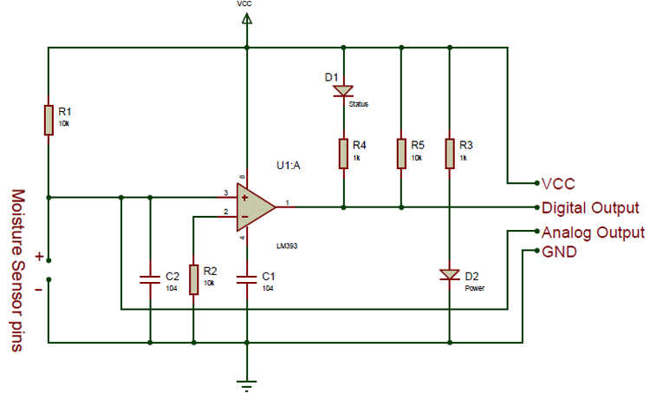

***fig2.2 Internal circuit diagram of soil moisture sensor.***

Using a Moisture sensor module with a microcontroller is very easy. Connect the Analog/Digital Output pin of the module to the Analog/Digital pin of Microcontroller. Connect VCC and GND pins to 5V and GND pins of the Microcontroller. After that insert the probe inside the soil. When there is more water present in the soil, it will conduct more electricity that means resistance will be low and the moisture level will be high.

**2.4.3 TEMPERATURE AND HUMIDITY SENSOR**

Temperature and humidity sensors are among the most commonly used environmental sensors. Humidity sensors are also sometimes referred to as hygrometers. These devices are used to provide the actual humidity condition within the air at any given point or in any given place. Such devices are commonly used in situations in which air conditions may be extreme or where air conditions need to be controlled due to varying reasons.The DHT22 sensor is the successor of the DHT11 module, it can either be purchased as a sensor or as a module. Either way the performance of the sensor is the same. The sensor will come as a 4-pin package out of which only three pins will be used whereas the module will come with just three pins as shown in the DHT22 pinout above.

The only difference between the sensor and module is that the module will have a filtering capacitor and pull-up resistor inbuilt, and for the sensor you have to use them externally if required.The module is slightly costly than the DHT11, but it has a higher measuring range and slightly better accuracy.The DHT22 is a commonly used Temperature and humidity sensor. The sensor comes with a dedicated NTC to measure temperature and an 8-bit microcontroller to output the values of temperature and humidity as serial data. The sensor is also factory calibrated and hence easy to interface with other microcontrollers.

The sensor can measure temperature from -40°C to 80°C and humidity from 0% to 100% with an accuracy of ±1°C and ±1%.The connection diagram for this sensor is shown in the fig.2.

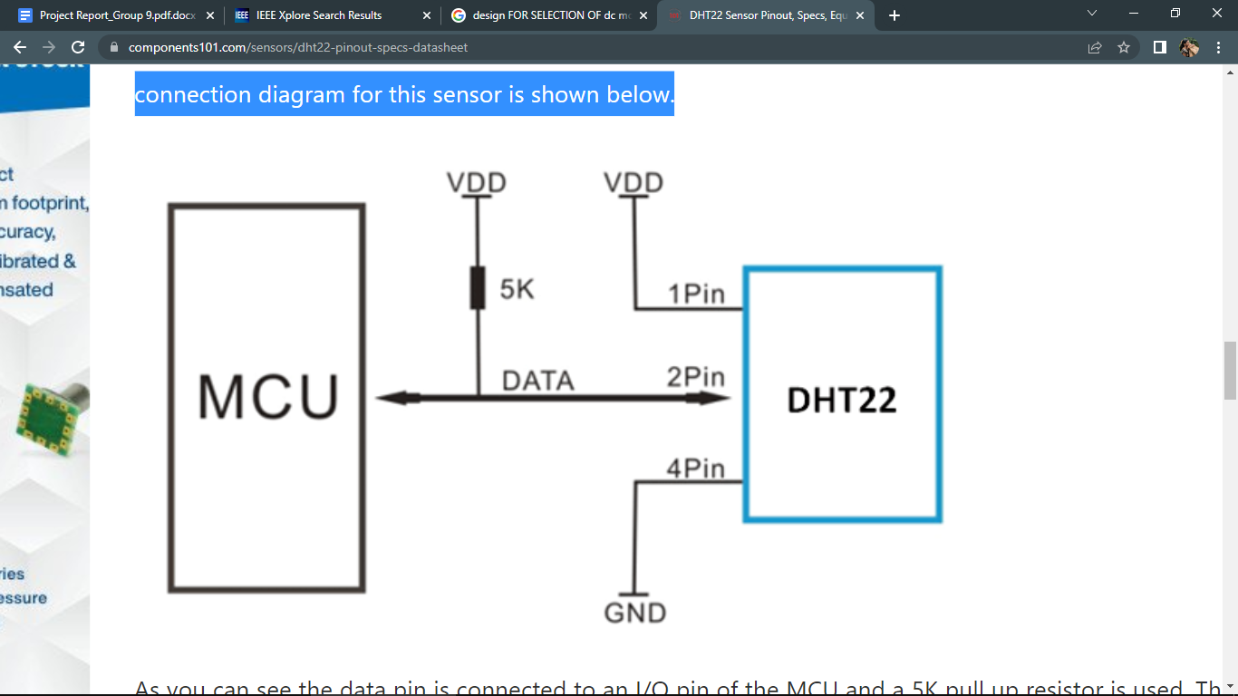

***fig2.3 Connection diagram of temperature and humidity sensor.***

Data pin is connected to an I/O pin of the MCU and a 5K pull up resistor is used.This data pin outputs the value of both temperature and humidity as serial data.To interface DHT22 with Arduino Uno there are ready made libraries for it which will give a quick start.

The output given out by the data pin will be in the order of 8bit humidity integer data + 8bit the Humidity decimal data +8 bit temperature integer data + 8bit fractional temperature data +8 bit parity bit.

**2.4.4 LIGHT SENSOR**

Light sensors, absorb the energy from light and change into electricity with the help of the photoelectric effect. The electricity produced will be proportional to the intensity of light which falls on the sensor and sensor material. With this principle, different wavelengths of light such as UV, IR, Ambient light, etc… can be measured. BH1750 is the sensor designed to measure ambient light.BH1750 is a Digital Ambient light sensor. It is easy to interface with a microcontroller, as it uses the I2C communication protocol.The SCL and SDA pins are for I2C. There is no calculation needed to measure the LUX value because the sensor directly gives the lux value. Actually, it measures the intensity according to the amount of light hitting on it. It operates on a voltage range of 2.4V-3.6V and consumes a really small current of 0.12mA. The results of the sensor does not depend upon the light source used and the influence of IR radiation is very less. There are very less chances of any error because the variation in measurement is as low as +/-20%.It consumes a very low amount of current. This sensor uses a photodiode to sense the light. This photodiode contains a PN junction. When light falls on it, electron-hole pairs are created in the depletion region. Due to the internal photoelectric effect, electricity is produced in the photodiode. This produced electricity is proportional to the intensity of light. This electricity is changed into a voltage by the Opamp.

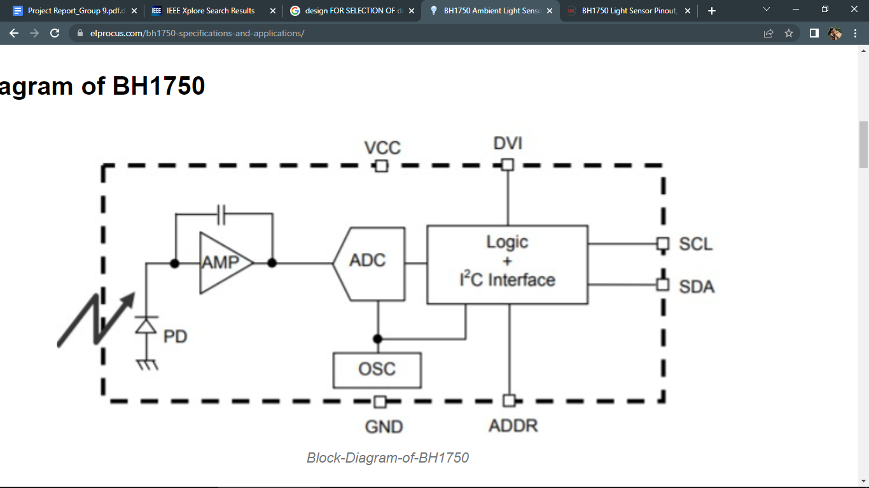

***fig2.4 Block diagram of light sensor.***

In the BH1750 sensor an Opamp – AMP is integrated which converts the current from the photodiode into voltage. BH1750 uses an ADC to convert the analog values provided by AMP into digital values. The logic+I2C block shown in the block diagram is the unit where illuminance values are converted to LUX and the I2C communication process takes place. OSC is the internal clock oscillator of 320kHz, used as a clock for internal logic.

**2.5 MOTOR CONTROLLERS**

A motor controller is a device or group of devices that can coordinate in a predetermined manner the performance of an electric motor [1]. A motor controller might include a manual or automatic means for starting and stopping the motor, selecting forward or reverse rotation, selecting and regulating the speed, regulating or limiting the torque, and protecting against overloads and electrical faults. Motor controllers may use electromechanical switching, or may use power electronics devices to regulate the speed and direction of a motor. Motor controllers can be manually, remotely or automatically operated. They may include only the means for starting and stopping the motor or they may include other functions. An electric motor controller can be classified by the type of motor it is to drive, such as permanent magnet, servo, series, separately excited, and alternating current. A motor controller is connected to a power source, such as a battery pack or power supply, and control circuitry in the form of analog or digital input signals.

**2.5.1 DIRECTION CONTROLLER - H BRIDGE**

An H bridge circuit is one of the simplest methods to control a DC motor. Figure 1 below shows a simplified circuit diagram of the H Bridge: 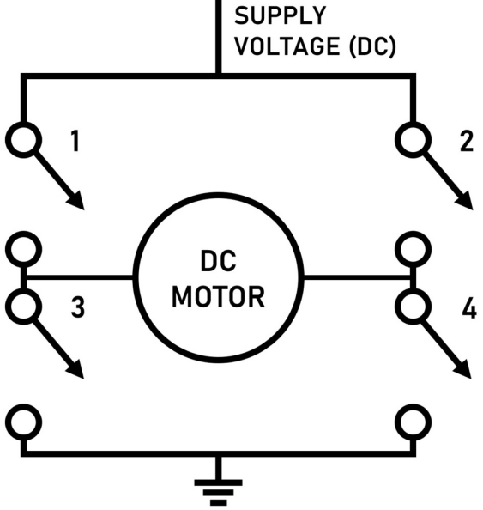

***fig2.5 H Bridge circuit for motor controller***

There are four switches controlled in pairs (1 & 4, 2 & 3), and when either of these pairs are closed, they complete the circuit and power the motor. A 4 quadrant motor can, therefore, be made by pairing certain switches together, where the changing polarities will create different effects on the motor. In essence, this circuit is switching the leads of the DC motor, which will reverse its rotational direction on command. They are readily sold as chips and can be found in most microprocessor-based controllers, as the H Bridge can be scaled down with transistors to very small sizes. Not only can H bridges reverse the motor direction, but they can also be used for speed control. If directional control is only desired, then the H bridge will be used as a so-called non-regenerative DC drive. However, more complexity can be added to create regenerative DC drives.

**2.5.2 SPEED CONTROLLER - PWM**

PWM can be used in many kinds of motors, as is seen in our article on AC motor controllers. Essentially, PWM circuits vary the motor speed by simulating a reduction/increase in supply voltage. Adjustable speed drive controllers send periodic pulses to the motor, which, when combined with the smoothing effect caused by coil inductance, makes the motor act as if it is being powered by a lower/higher voltage. For example, if a 12 V motor is given a PWM signal that is high (12 V) for two-thirds of each period and low (0 V) for the remainder, the motor will effectively operate at two-thirds the full voltage, or 8 V. The percentage of voltage reduction, or the PWM “duty cycle”, will therefore change the speed of the motor. PWM is both easy and inexpensive to implement, and virtually any duty cycle can be chosen, allowing for almost continuous control of motor speed. PWM is often paired with H bridges to allow for both speed, direction, and braking control.

**2.5.3 APPLICATIONS OF MOTOR CONTROLLERS**

* Multi-axis controllers are used to control and monitor multiple, independent axes of motion.
* Robotic motion controllers use digital motion control hardware and software for the coordinated multi-axis control of industrial robots and robotic systems.
* Servo amplifiers are electronic modules that convert low level analog command signals to high power voltages and currents.
* Inverter drives convert AC power inputs to DC outputs.
* High frequency drives supply power to AC motors at frequencies that are considerably higher than those used in standard-power applications.
* Regenerative drives support motor braking.
* Variable speed drives support speed control and adjustment.

**2.6 SERVO MOTORS**

A servo motor is a type of motor that can rotate with great precision. Normally this type of motor consists of a control circuit that provides feedback on the current position of the motor shaft, this feedback allows the servo motors to rotate with great precision. If you want to rotate an object at some specific angles or distance, then you use a servo motor. It is just made up of a simple motor which runs through a servo mechanism. If the motor is powered by a DC power supply then it is called a DC servo motor, and if it is AC-powered motor then it is called AC servo motor. Apart from these major classifications, there are many other types of servo motors based on the type of gear arrangement and operating characteristics. A servo motor usually comes with a gear arrangement that allows us to get a very high torque servo motor in small and lightweight packages. Due to these features, they are being used in many applications like toy cars, RC helicopters and planes, Robotics, etc.

Servo motors are rated in kg/cm (kilogram per centimeter) most hobby servo motors are rated at 3kg/cm or 6kg/cm or 12kg/cm. This kg/cm tells you how much weight your servo motor can lift at a particular distance. For example: A 6kg/cm Servo motor should be able to lift 6kg if the load is suspended 1cm away from the motors shaft, the greater the distance the lesser the weight carrying capacity. The position of a servo motor is decided by electrical pulse and its circuitry is placed beside the motor.

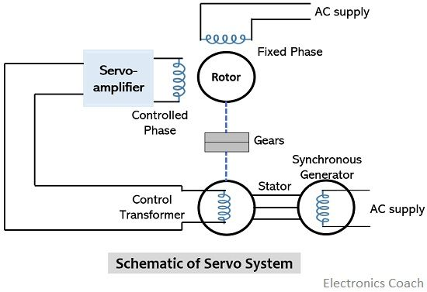

***fig 2.6 Schematic of Servo Motor.***

**2.6.1 SERVO MOTOR WORKING PRINCIPLE**

It is a closed-loop system where it uses a positive feedback system to control motion and the final position of the shaft. Here the device is controlled by a feedback signal generated by comparing output signal and reference input signal.

Here the reference input signal is compared to the reference output signal and the third signal is produced by the feedback system. And this third signal acts as an input signal to control the device. This signal is present as long as the feedback signal is generated or there is a difference between the reference input signal and reference output signal. So the main task of servomechanism is to maintain the output of a system at the desired value in the presence of noises.

**2.6.2 CONTROLLING SERVO MOTOR**

Servo motor is controlled by PWM (Pulse width Modulation) which is provided by the control wires. There is a minimum pulse, a maximum pulse and a repetition rate. Servo motor can turn 90 degrees from either direction from its neutral position. The servo motor expects to see a pulse every 20 milliseconds (ms) and the length of the pulse will determine how far the motor turns. For example, a 1.5ms pulse will make the motor turn to the 90° position, such as if the pulse is shorter than 1.5ms the shaft moves to 0° and if it is longer than 1.5ms then it will turn the servo to 180°. Servo motor works on PWM (Pulse width modulation) principle, meaning its angle of rotation is controlled by the duration of applied pulse to its Control PIN. Basically a servo motor is made up of a DC motor which is controlled by a variable resistor (potentiometer) and some gears. High speed force of the DC motor is converted into torque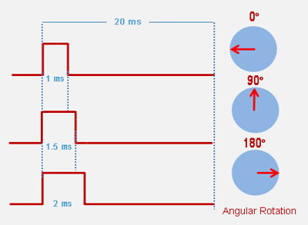.

***fig 2.7 . Position control of servo motor using PWM***

**2.7 WIFI DEVELOPMENT BOARDS**

NodeMCU Development board is featured with wifi capability, analog pin, digital pins, and serial communication protocols.Microchip IoT development boards are designed to easily connect an embedded system to cloud servers such as Amazon Web Services, Google Cloud, Blynk cloud etc. These boards provide learning development tools to prototype and accelerate development cycles, providing an all in one solution. The modules include TCP/IP stacks and networking services with full certifications. The WiFi modules also offer various I/Os, analog inputs, and serial interfaces that include SPI and UART.

**2.7.1 ESP32**

ESP32 is a low-cost System on Chip (SoC) Microcontroller from Espressif Systems, the developers of the ESP8266 SoC. It is a successor to ESP8266 SoC and comes in both single-core and dual-core variations of Tensilica's 32-bit Xtensa LX6 Microprocessor with integrated Wi-Fi and Bluetooth. The good thing about ESP32, like ESP8266 is its integrated RF components like Power Amplifier, Low-Noise Receive Amplifier, Antenna Switch, Filters and RF Balun. This makes designing hardware around ESP32 very easy as you require very few external components.

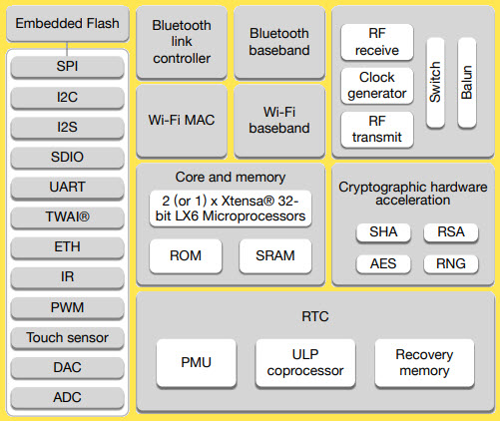

***fig 2.8 Internal architecture of ESP32***

**2.7.2 ESP8266**

The ESP8266 WiFi Module is a self contained SOC with integrated TCP/IP protocol stack that can give any microcontroller access to your WiFi network. The ESP8266 is capable of either hosting an application or offloading all WiFi networking functions from another application processor. Each ESP8266 module comes pre-programmed with an AT command set firmware, meaning, we can simply hook this up to your Arduino device and get about as much WiFi-ability.The ESP8266 module is an extremely cost effective board with a huge, and ever growing, community.This module has a powerful enough on-board processing and storage capability that allows it to be integrated with the sensors and other application specific devices through its GPIOs with minimal development up-front and minimal loading during runtime. Its high degree of on-chip integration allows for minimal external circuitry, including the front-end module, which is designed to occupy minimal PCB area. The ESP8266 supports APSD for VoIP applications and Bluetooth coexistence interfaces, it contains a self-calibrated RF allowing it to work under all operating conditions, and requires no external RF parts.

The ESP8266 module works with 3.3V only, anything more than 3.7V would kill the module hence be cautions with your circuits. The best way to program an ESP-01 is by using the FTDI board that supports 3.3V programming.The module is a bit power hungry while programming and hence you can power it with a 3.3V pin on Arduino or use a potential divider.it is important to make a small voltage regulator for 3.31v that could supply a minimum of 500mA.A simplified circuit diagram for using the ESP8266-01 module is given in fig.7.The switch SW2 (Programming Switch) should be held pressed to hold the GPIO-0 pin to ground. This way we can enter into the programming mode and upload the code. Once the code is released the switch can be released.

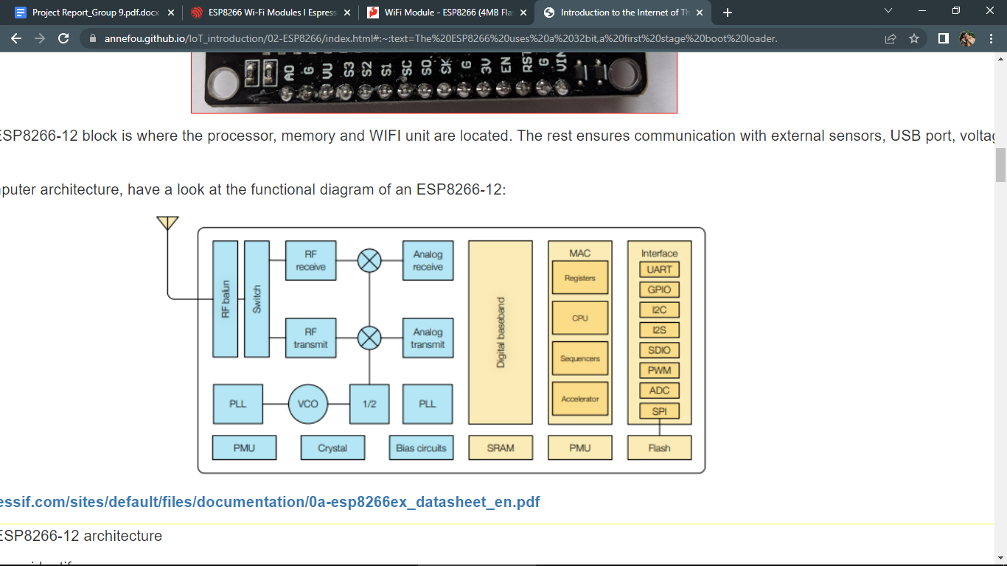

***fig 2.9 Internal architecture of ESP8266***

**2.8 GEAR MOTORS**

  Gear motors are electric motors that use a sort of gear system on the motor’s output. This gearing configuration is known as a gear reducer or gearbox. Combining an electric motor and a gearbox saves design cost and complexity, especially for motors designed for high torque and low-speed purposes. Furthermore, gearboxes can be employed to reorient the output shaft in a different direction.A gearmotor delivers high torque at low horsepower or low speed. The speed specifications for these motors are normal speed and stall-speed torque. These motors use gears, typically assembled as a gearbox, to reduce speed, which makes more torque available. Gearmotors are most often used in applications that need a lot of force to move heavy objects.

**2.8.1 DIAGRAM OF GEAR MOTOR**

The gear having smaller radius will cover more RPM than the one with larger radius. However, the larger gear will give more torque to the smaller gear than vice versa. The comparison of angular velocity between input gear (the one that transfers energy) to output gear gives the gear ratio. When multiple gears are connected together, conservation of energy is also followed. The direction in which the other gear rotates is always the opposite of the gear adjacent to it. In any DC motor, RPM and torque are inversely proportional. Hence the gear having more torque will provide a lesser RPM and converse. In a geared DC motor, the concept of pulse width modulation is applied

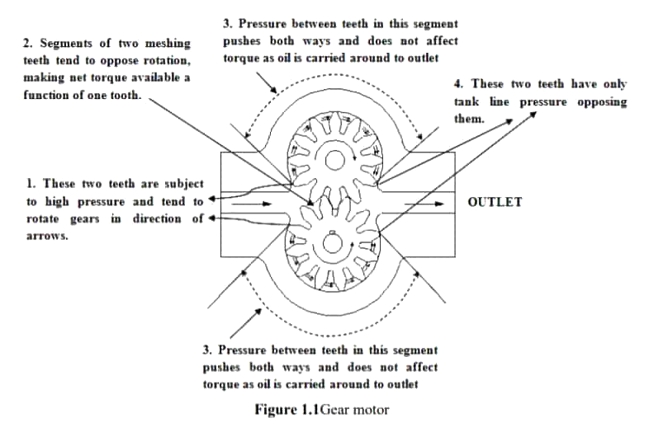

***fig 2.10 Mechanism of gear motor***

**2.8.2 APPLICATIONS OF GEAR MOTORS**

Gear motors are used in applications that require high output torque and lower output shaft rotational speed, especially where space and available power are limited. This describes a wide range of common equipment applications across multiple industries.

* Transport and logistics systems
* Automotive, throughout the production process
* Food & beverage, from packaging to filling
* Robots and handling machines

**2.9 ESP32 CAM BOARD**

The ESP32-CAM is a small size, low power consumption camera module based on the ESP32 WIFI development board. It comes with an OV2640 camera and it also features a microSD card slot that can be useful to store images taken with the camera or to store files to serve to clients. The ESP32-CAM is suitable for home automation and smart devices, industrial wireless control, wireless video monitoring, QR wireless identification, WiFi image upload, wireless face recognition and other IoT applications. It is an ideal solution for IoT applications.

**2.9.1 FEATURES OF ESP32 CAM BOARD**

* Onboard ESP32-S module, supports WiFi + Bluetooth
* OV2640 camera with built-in flash lamp Onboard microSD card slot
* Supports up to 4G TF card for data storage
* Supports WiFi video monitoring and WiFi image upload
* Supports multi sleep modes, deep sleep current as low as 6mA
* Control interface is accessible via pin-header
* Easy to be integrated and embedded into user products.

**2.10** **3D PRINTING**

3D printing, also known as additive manufacturing, is a method of creating a three dimensional object layer-by-layer using a computer created design. 3D printing is an additive process whereby layers of material are built up to create a 3D part. This is the opposite of subtractive manufacturing processes, where a final design is cut from a larger block of material. As a result, 3D printing creates less material wastage.

3D printable models may be created with a computer-aided design (CAD) package, via a 3D scanner, or by a plain digital camera and photogrammetry software. 3D printed models created with CAD result in relatively fewer errors than other methods. Errors in 3D printable models can be identified and corrected before printing. The manual modeling process of preparing geometric data for 3D computer graphics is similar to plastic arts such as sculpting. 3D scanning is a process of collecting digital data on the shape and appearance of a real object, creating a digital model based on it.The starting point for any 3D printing process is a 3D digital model, which can be created using a variety of 3D software programmes in industry this is 3D CAD, for Makers and Consumers there are simpler, more accessible programmes available or scanned with a 3D scanner. The model is then ‘sliced’ into layers, thereby converting the design into a file readable by the 3D printer. The material processed by the 3D printer is then layered according to the design and the process. As stated, there are a number of different types of 3D printing technologies, which process different materials in different ways to create the final object.

**2.11 BLYNK INTERFACE**

Blynk was designed for the Internet of Things. It can control hardware remotely, it can display sensor data, it can store data, visualize it and do many other cool things. There are three major components in the platform:

* Blynk App - allows you to create amazing interfaces for your projects using various widgets we provide.
* Blynk Server - responsible for all the communications between the smartphone and hardware. You can use our Blynk Cloud or run your private Blynk server locally. It’s open-source, could easily handle thousands of devices and can even be launched on a Raspberry Pi.
* Blynk Libraries - for all the popular hardware platforms - enable communication with the server and process all the incoming and outcoming commands.

Blynk offers native iOS and Android mobile apps which allow to remotely control connected devices and visualize data from them.

App operates in two modes:

### **Developer Mode**

The primary function of Developer Mode in the mobile app is to build and edit the Mobile Dashboard User interface (GUI) for the given Device Template.

Mobile Dashboard is built from Widgets - modular UI elements which can be positioned on the canvas. Every Widget serves a special function (a button, a slider, a chart, etc). Every Widget has it's own settings based on its functionality**.**

### **End-user mode**

This mode is used by both the makers and the end-users. It's focused on devices, automations and notifications view and management with the help of widgets and additional screens containing specific information about data that is set/sent/received to/from Blynk.Cloud and devices.

**2.12 BATTERY**

The battery used in this project is a rechargeable Li-ion battery.A rechargeable battery, storage battery, or secondary cell (formally a type of energy accumulator), is a type of electrical battery which can be charged, discharged into a load, and recharged many times, as opposed to a disposable or primary battery, which is supplied fully charged and discarded after use. It is composed of one or more electrochemical cells. The term "accumulator" is used as it accumulates and stores energy through a reversible electrochemical reaction. Rechargeable batteries are produced in many different shapes and sizes, ranging from button cells to megawatt systems connected to stabilize an electrical distribution network.Rechargeable batteries has initial cost more than disposable batteries, but have a much lower total cost of ownership and environmental impact, as they can be recharged inexpensively many times before they need replacing. A lithium-ion battery or Li-ion battery is a type of rechargeable battery composed of cells in which lithium ions move from the negative electrode through an electrolyte to the positive electrode during discharge and back when charging. Li-ion cells use an intercalated lithium compound as the material at the positive electrode and typically graphite at the negative electrode. Li-ion batteries have a high energy density, no memory effect (other than LFP cells)and low self-discharge. Cells can be manufactured to prioritize either energy or power density.They can however be a safety hazard since they contain flammable electrolytes and if damaged or incorrectly charged can lead to explosions and fires.

**2.13 VOLTAGE REGULATORS**

A voltage regulator is one of the most widely used electronic circuitry in any device. A regulated voltage (without fluctuations & noise levels) is very important for the smooth functioning of many digital electronic devices. A common case is with micro controllers, where a smooth regulated input voltage must be supplied for the micro controller to function smoothly.It is an integrated circuit whose basic purpose is to regulate the unregulated input voltage (definitely over a predefined range) and provide with a constant, regulated output voltage.An IC based voltage regulator can be classified in different ways. A common type of classification is 3 terminal voltage regulator and 5 or multi terminal voltage regulator. Another popular way of classifying IC voltage regulators is by identifying them as linear voltage regulators & switching voltage regulators. There is a third set of classification as 1) Fixed voltage regulators (positive & negative) 2) Adjustable voltage regulators (positive & negative) and finally 3) Switching regulators. In the third classification, fixed & adjustable regulators are basically versions of linear voltage regulators

.

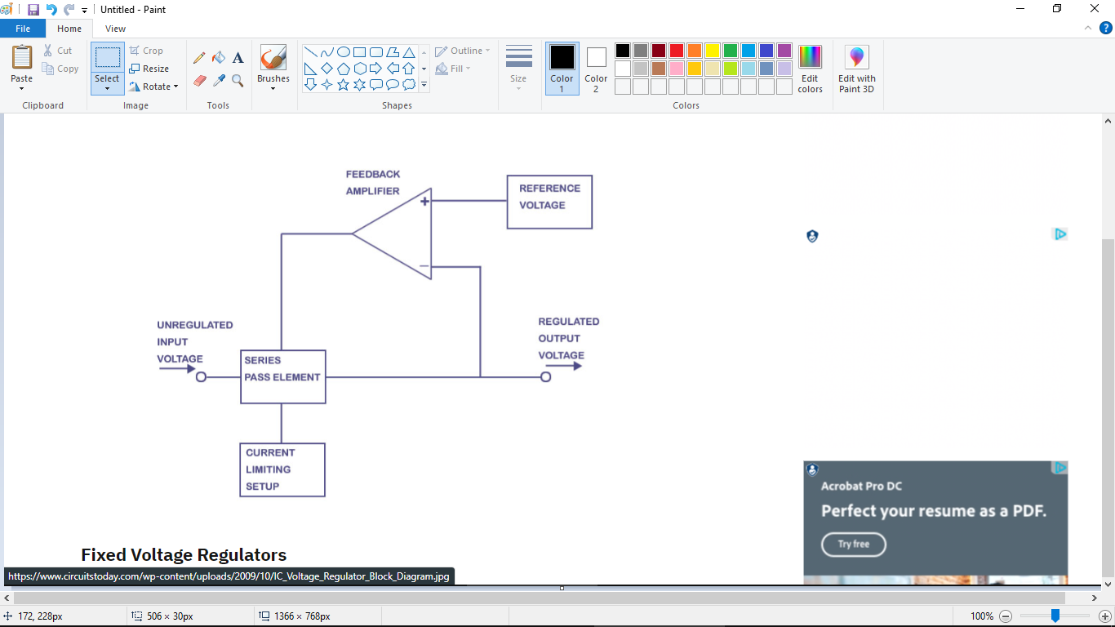

***fig 2.11 Block diagram of an IC based voltage regulator.***

**CHAPTER-3**

**FIELD MONITORING ROBOT AND ON FIELD CONTROLLER UNIT**

**3.1 CHAPTER OVERVIEW**

This chapter deals with components, functions, features, applications, as well as operation of the agriculture monitoring robot and on field controller unit.

**3.2 BASIC PRINCIPLE OF AGRICULTURE MONITORING ROBOT**

A Smart Agriculture Robotic System is developed through the application of advanced technologies including sensors, automation,path planning etc through robotics and IoT with cloud computing. The Robotic Car can move all over the field and is able to collect data regarding various farm parameters [4]. This area wise monitoring can provide highly efficient control of irrigation and humidity inside the greenhouse. The robot is driven by 4 gear motors enabling it to maneuver in all four directions. It is also provided with an on board camera for enabling live streaming [2][5].

Different types of sensors like soil moisture sensor, light sensor, temperature and humidity sensors are attached to the robot for collecting data from the farm. In order to take the soil moisture readings the moisture sensor needs to be inserted into the soil. This is done by using a robotic arm attached to the robot which is operated by a servo motor. All the collected data as well as the live visuals are uploaded to the blynk cloud from where it is transferred to the blynk interface on the smartphone [10].

**3.3 BLOCK DIAGRAM**

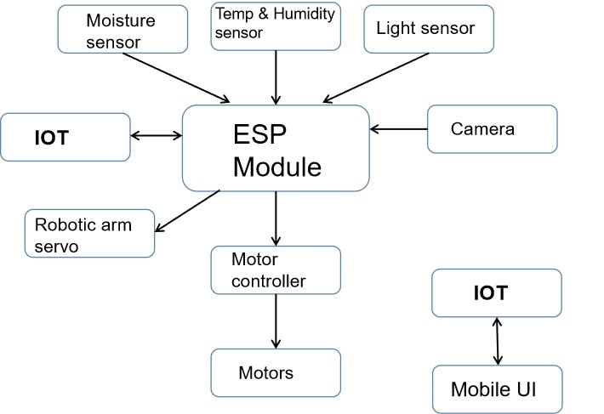

***Figure 3.1: Block Diagram of Robot***

**3.3.1 ESP32 MODULE**

ESP32 is the microcontroller used for the robot car. It receives the readings from various sensor modules, processes the received data and uploads the results to the blynk cloud. It also performs the control of the 4 motors for driving the robot as well as the servo motors.

**3.3.2 MOISTURE SENSOR**

The moisture sensor is used to measure the moisture percentage in the soil. It is attached to one end of the robotic arm.

**3.3.3 TEMPERATURE AND HUMIDITY SENSOR**

It reads the temperature and humidity from the robot’s surroundings.

**3.3.4 LIGHT SENSOR**

The light sensor measures the amount of sunlight received in the farm area.

**3.3.5 CAMERA MODULE**

The camera module captures the visuals from the robot’s surroundings and uploads it to the cloud. It is mounted on top of a servo motor to get a wider field of view.

**3.3.6 MOTOR DRIVER**

The motor driver is responsible for controlling the direction and speed of the 4 motors which drive the robot. Its output is based on the signals received from the ESP32 module.

**3.3.7 GEAR MOTORS**

Four gear motors are provided for driving the robot. These motors have high torque and low rpm making them suitable for maneuvering through the rough surface of the field.

**3.3.8 SERVO MOTORS**

The robot has two servo motors. One for controlling the operation of the robotic arm and the other for changing the field of view of the camera module.

**3.4 FUNCTIONS PERFORMED BY THE ROBOT**

* Measures the soil moisture
* Measures the sunlight intensity, temperature and humidity inside the greenhouse
* Provides live visuals of the farm area to the farmer
* Uses a robotic arm to take accurate readings from the soil by inserting the sensor deep into the soil
* Automatically reaches the location specified by the user by using path planning

**3.5 BASIC PRINCIPLE OF ON FIELD CONTROLLER UNIT**

The on field controller is placed inside the greenhouse. Its main function is to control the operation of the water pump and the exhaust fan. This is done manually based on the control signals from the farmer or automatically based on the measured values from the sensors. The on field control unit consists of an ESP8266 wifi module, motor drivers, water pump and exhaust fan. The operation of the water pump and exhaust fan is controlled by the motor driver based on the signals received from the ESP8266 module. The unit receives the control signals from the user through the Blynk cloud and controls both operation time and speed of pump and exhaust fan to maintain optimum growing conditions for the crops with minimum use of water and electrical energy [6].

**3.6 BLOCK DIAGRAM OF ON FIELD CONTROL UNIT**

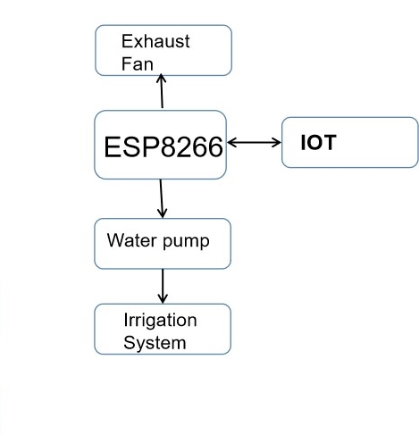

***Figure 3.2: Block Diagram of on field control unit***

**3.6.1 ESP8266 MODULE**

ESP8266 is the microcontroller used for the on field controller unit. It can be connected to a wifi network to enable communication with the user and Blynk cloud. Based on the received data it perform the control of operation time and speed of water pump and exhaust fan.

**3.6.2 WATER PUMP**

The water pump performs the actual irrigation of the field area. Both the speed and operating time of the pump is controlled by the ESP8266 module according to the measured soil moisture value.

**3.6.3 EXHAUST FAN**

The function of the exhaust fan is to control the humidity and temperature inside the greenhouse. Its operation is also controlled by the esp8266 microcontroller.

**CHAPTER 4**

**SELECTION AND DESIGN OF COMPONENTS**

**4.1 CHAPTER OVERVIEW**

This chapter sheds light on how the project is advanced from components selection, software selection, programming, circuit construction and to simulation results. It also summarises the cost expected for the hardware implementation.

**4.2 COMPONENTS SELECTION AND DESIGN**

Basic components like DC geared motor, Battery, soil moisture sensor, temperature and humidity sensor, light sensor, esp32 module, esp8266 module

**4.2.1 DC GEARED MOTOR**

Weight Calculation

Battery=309 g

Motor+Wheels=150∗4=600g

ESP32=140g

Camera=40g

Motor Controller=25g

Light sensor=1.1g

Temperature and humidity sensor=2.4g

Soil moisture sensor=20g

Servo motors=120g

Circuit board=40g

Base board=200g

Total weight=1.6kg

Friction coefficient=μs=0.65

Desired velocity, V=1m/s

Wheel radius, r=3 cm

Angular velocity, ω= V/r =33 rad/s

Frictional force, Ff = μs * Wsystem

=0.65*1.6

=1.04

Msystem= Wsystem/9.8=0.40

amax= Ff/Msystem =0.65*9.8=6.37

Tmax= μs*g*(r*Msystem+(1/2*Mwheel*r^2)/r)

=0.65 Nm

Tmax/4=0.164 Nm=1.64 KgCm

Power=T*ω

=5.4 W

rpm of motor=ω*60/2π=315.12

**Motor Specification ; 300 rpm,2kgcm**

**4.2.2 BATTERY SIZING**

Components and Power ratings

ESP32 Microcontroller = 240 mW

Soil moisture sensor = 25 mW

DHT22 = 12.5 mW

BH1750 = 3.6 mW

OV7670 = 60 mW

Motor controller = 180 mW

Motor (4∗4) = 16W

Total power requirement = 16.4 W

Total no of working hours = 4 hrs

Total Wh needed = Total power requirement ∗ Total no of working hrs

= 65.6 Wh

Watthour required with 10% loss = 72.16 Wh

Watthour required with 0.9 DOD = 72.16/0.9

= 80.174 Wh

Battery voltage = 12 V

Ah capacity required = 80.174/12= 6.68= 7Ah

**Battery Specification ; 12 V,7000 mAh**

**4.2.3 BH1750**

**TABLE I**

**TECHNICAL SPECIFICATIONS OF BH1750**

|  |  |  |
| --- | --- | --- |
| **Sl. No.** | **Features** | **Specifications** |
| 1 | Power Supply | 2.4V-3.6V (typically 3.0V) |
| 2 | Less current consumption | 0.12mA |
| 3 | Measuring Range | 1-65535lx |
| 4 | Communication | I2C bus |
| 5 | Accuracy | +/-20% |

**4.2.4 DHT22**

**TABLE II**

**TECHNICAL SPECIFICATIONS OF DHT22**

|  |  |  |
| --- | --- | --- |
| **Sl. No.** | **Features** | **Specifications** |
| **1** | Operating Voltage | 3.5V to 5.5V |
| **2** | Operating current | 0.3mA (measuring) 60uA (standby) |
| **3** | Temperature Range | -40°C to 80°C |
| **4** | Humidity Range | 0% to 100% |
| **5** | Resolution | Temperature and Humidity both are 16-bit |
| **6** | Accuracy | ±0.5°C and ±1% |

**4.2.5 XH-M214**

**TABLE III**

**TECHNICAL SPECIFICATIONS OF XH-M214**

|  |  |  |
| --- | --- | --- |
| **Sl. No.** | **Features** | **Specifications** |
| **1** | Working Voltage | DC 12V |
| **2** | Load Voltage | AC 250V /DC 30V |
| **3** | Humidity range | 20-99% RH |
| **4** | Control precision | 1% RH |
| **5** | Control current | 10A |
| **6** | Weight | 20 g |
| **7** | Dimension | 52 * 43 * 16 mm |

**4.2.6 L298N DRIVER**

**TABLE IV**

**TECHNICAL SPECIFICATIONS OF L298N DRIVER**

|  |  |  |
| --- | --- | --- |
| **Sl. No.** | **Features** | **Specifications** |
| 1 | Driver Chip | Double H Bridge L298N |
| 2 | Motor Supply Voltage (Maximum | 46V |
| 3 | Motor Supply Current (Maximum) | 2A |
| 4 | Logic Voltage | 5V |
| 5 | Driver Voltage | 5-35V |
| 6 | Driver Current | 2A |
| 7 | Logical Current | 0-36mA |
| 8 | Maximum Power (W) | 25W |

**4.2.7 ESP32**

**TABLE V**

**TECHNICAL SPECIFICATIONS OF ESP32**

|  |  |  |
| --- | --- | --- |
| **Sl. No.** | **Features** | **Specifications** |
| 1 | Microcontroller | 32-bit LX6 |
| 2 | Operating Voltage | 5V |
| 3 | Input Voltage (Recommended) | 7-12V |
| 4 | Input Voltage (Limits) | 2.2-3.6V |
| 5 | Digital I/O Pins | 39 pins |
| 6 | Analog Input Pins | 12-bit, 18 channel |
| 7 | DC Current I/O Pin | 40mA |
| 8 | DC Current for 3.3V Pin | 50mA |
| 9 | Flash Memory | 16MB |
| 10 | SRAM | 520KB |
| 11 | EEPROM | 4096 Bytes |
| 12 | Clock Speed | 80-240MHz |

**4.2.8 ESP8266**

**TABLE VI**

**TECHNICAL SPECIFICATIONS OF ESP8266**

|  |  |  |
| --- | --- | --- |
| **Sl. No.** | **Features** | **Specifications** |
| 1 | Microcontroller | 32-bit |
| 2 | Architecture | Harward architecture |
| 3 | Operating Voltage | 5 V |
| 4 | Flash Memory | 512kB |
| 5 | SRAM | 400kB |
| 6 | Clock Speed | 80MHz |
| 7 | Analog I/O Pins | 1 ADC pin |
| 8 | EEPROM | 4kB |
| 9 | DC Current per I/O Pins | 12mA |
| 10 | Input Voltage | 3.3V |
| 11 | Digital I/O Pins | 17 GPIO Pins |
| 12 | PWM Output | Range: 0-254 |
| 13 | Power Consumption | o/p current:1A, 1.1V at 800mA |
| 14 | PCB Size | 49*24.5*13 |
| 15 | Weight | 1.72g |
| 16 | Product Code |  |

**4.2.9 ESP CAMBOARD**

**TABLE VII**

**TECHNICAL SPECIFICATIONS OF ESP32 CAM BOARD**

|  |  |  |
| --- | --- | --- |
| **Sl. No.** | **Features** | **Specifications** |
| 1 | Microcontroller | 32-bit |
| 2 | Architecture | 7-stage pipeline architecture, On-chip sensor, hall sensor, Temperature sensor |
| 3 | Operating Voltage | 5 V |
| 4 | Flash Memory | 16MB |
| 5 | SRAM | 520KB |
| 6 | Clock Speed | 80-240MHz |
| 7 | Analog I/O Pins | 3 GND pins, 2 Power pins |
| 8 | EEPROM | 512KB |
| 9 | DC Current per I/O Pins | 40mA |
| 10 | Input Voltage | 5V |
| 11 | Digital I/O Pins | 39 (34-GPIO) |
| 12 | PWM Output | 16 channels |
| 13 | Power Consumption | 1.44mAh |
| 14 | PCB Size |  |
| 15 | Weight | 20g |
| 16 | Product Code |  |

**4.2.10 SG90 SERVO**

**TABLE VIII**

**TECHNICAL SPECIFICATIONS OF SG90 SERVO**

|  |  |  |
| --- | --- | --- |
| **Sl. No.** | **Features** | **Specifications** |
| 1 | Operating Voltage | +5V |
| 2 | Torque | 2.5 kgcm |
| 2 | Operating speed | 0.1s/60° |
| 4 | Gear Type | Plastic |
| 5 | Rotation | 0°-180° |
| 6 | Weight of motor | 9gm |

**4.2.11 MG995 SERVO**

**TABLE IX**

**TECHNICAL SPECIFICATIONS OF MG995 SERVO**

|  |  |  |
| --- | --- | --- |
| **Sl. No.** | **Features** | **Specifications** |
| 1 | Operating voltage range | 4.8 V to 7.2 V |
| 2 | Stall torque | 9.4kg/cm (4.8v); 11kg/cm (6v) |
| 3 | Operating speed | 0.2 s/60º (4.8 V), 0.16 s/60º (6 V) |
| 4 | Rotational degree | 180º |
| 5 | Dead band width | 5 μs |
| 6 | Operating temperature range | 0ºC to +55ºC |
| 7 | Current draw at idle | 10mA |
| 8 | No load operating current draw | 170mA |
| 9 | Current at maximum load | 1200mA |
| 10 | Weight | 55 g |
| 11 | Dimension | 40.7×19.7×42.9mm |

**4.2.12 ROBOTIC ARM-3D MODEL**

A robotic arm is used to insert the soil moisture sensor into the soil to take accurate readings. Functions are performed with pre-written programs and no human interaction. The soil moisture sensor is attached to one end of the arm and is operated by a servo motor. Designed a 3D model of the robotic arm and printed it using 3D printer.

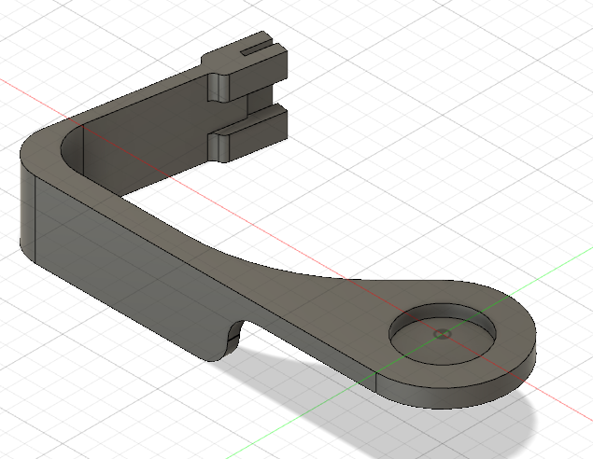

***Figure 4.1: 3D Model of robotic arm***

**4.3 SOFTWARE SELECTION**

C language is chosen to write the program for the ESP32, ESP8266 and ESP32 CAM BOARD . The C programming is written in Arduino Integrated Development Environment (IDE) software. Various libraries were installed for writing programs for each of these boards.

**4.3.1 PROTEUS**

Proteus is software for microprocessor and microcontroller simulation, schematic capture, and printed circuit board (PCB) design. It is developed by Lab center Electronics. Figure 4.3 shows the Proteus window.

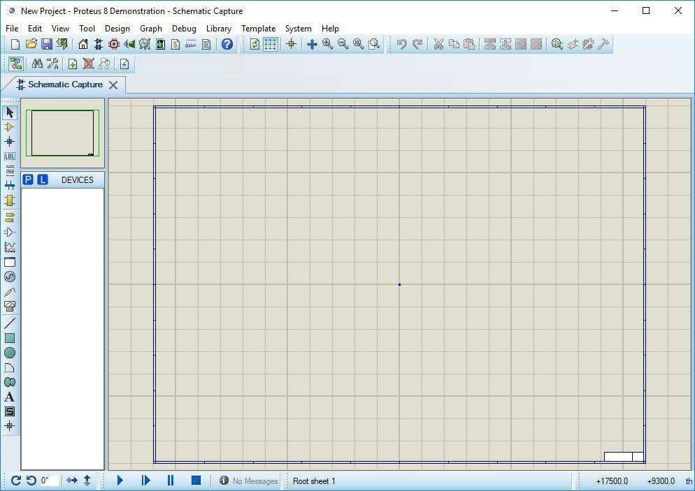

Proteus consists of a single application with many modules such as ISIS Schematic Capture to design the buck converter circuit and VSM mode to simulate the buck converter circuit.

**4.3.2 ARDUINO IDE**

The Arduino Integrated Development Environment - or Arduino Software (IDE) - contains a text editor for writing code, a message area, a text console, a toolbar with buttons for common functions and a series of menus. It connects to the Arduino and ESP hardware to upload programs and communicate with them.

**4.3.3 EASYEDA**

EasyEDA is a web-based EDA tool suite that enables hardware engineers to design, simulate, share - publicly and privately - and discuss schematics, simulations and printed circuit boards. Other features include the creation of a bill of materials, Gerber files and pick and place files and documentary outputs in PDF, PNG and SVG formats. EasyEDA allows the creation and editing of schematic diagrams, SPICE simulation of mixed analogue and digital circuits and the creation and editing of printed circuit board layouts and, optionally, the manufacture of printed circuit boards.

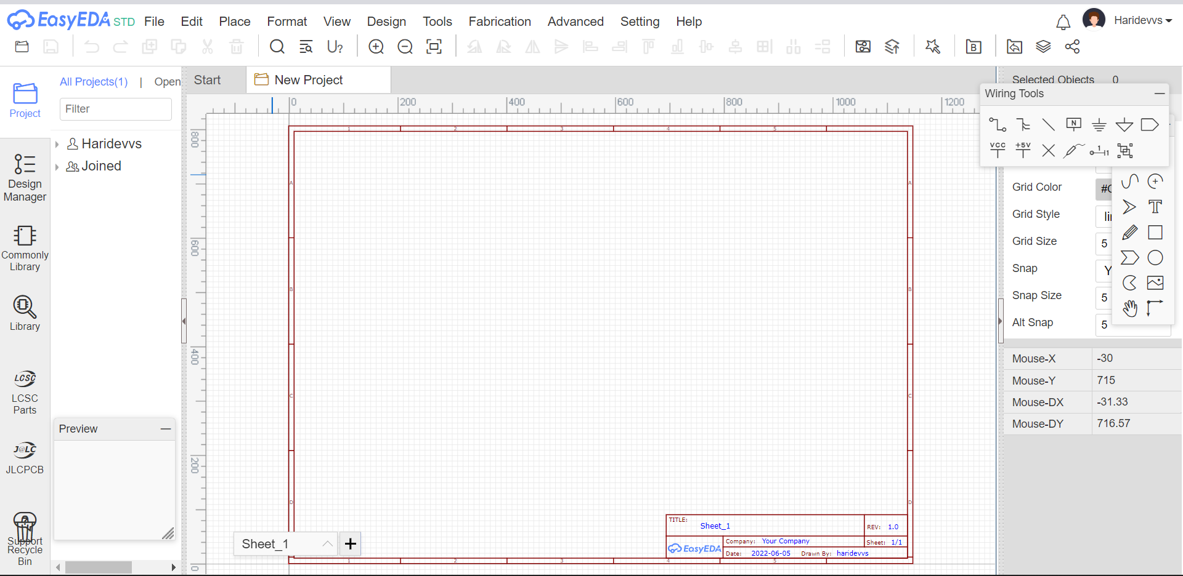

**4.4 COST ESTIMATION**

The complete cost estimated for “ IoT Based Smart Agriculture Monitoring System ” in accordance with the proposed design parameters is provided in Table IV.

**TABLE X**

**COST ESTIMATION**

|  |  |  |
| --- | --- | --- |
| **Sl. No** | **COMPONENTS** | **COST(in Rupees)** |
|  | Li-ion battery | 2200 |
|  | Voltage Regulator | 30 |
|  | ESP32 | 600 |
|  | ESP8266 | 400 |
|  | ESP32 CAM | 900 |
|  | Servo Motors | 550 |
|  | Soil moisture sensor | 350 |
|  | DHT22 | 300 |
|  | BH1750 | 250 |
|  | Gear motors | 1200 |
|  | Base Board | 300 |
|  | L298N | 506 |
|  | Water Pump | 350 |
|  | Exhaust Fan | 320 |
| 15. | Greenhouse setup and crops | 1800 |
| 16. | Miscellaneous | 670 |

The total estimated cost was around **Rs. 10720**.

**CHAPTER 5**

**SIMULATION STUDIES AND FLOW CHARTS**

**5.1 CHAPTER OVERVIEW**

This chapter showcases the PROTEUS simulation, flow charts of operations to be performed by the system.

**5.2 SIMULATION OF SENSORS AND MOTOR DRIVER**

To test the operation and working of various sensors the simulation of sensor circuits was done with arduino uno in Proteus. The light sensor and temperature, humidity sensors were initially tested. Then the soil moisture circuit was also included in the simulation.

The operation of motor driver L298N was also tested in the simulation. Both direction and speed of 2 motors was controlled independently.

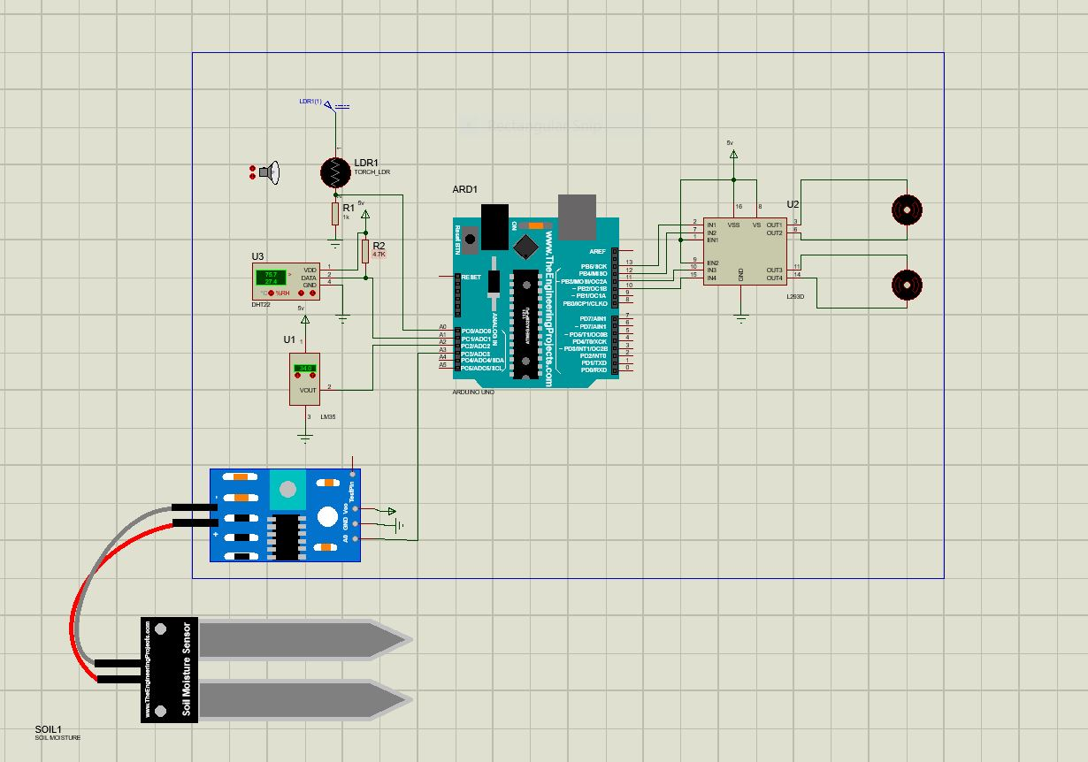***Figure 5.1 Simulation of sensors and motor driver***

**5.2.1 TEST RESULTS OF DHT11 AND DHT22 SENSORS**

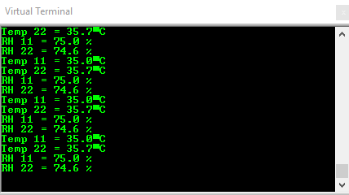

**5.2.2 TEST RESULTS OF LIGHT SENSOR**

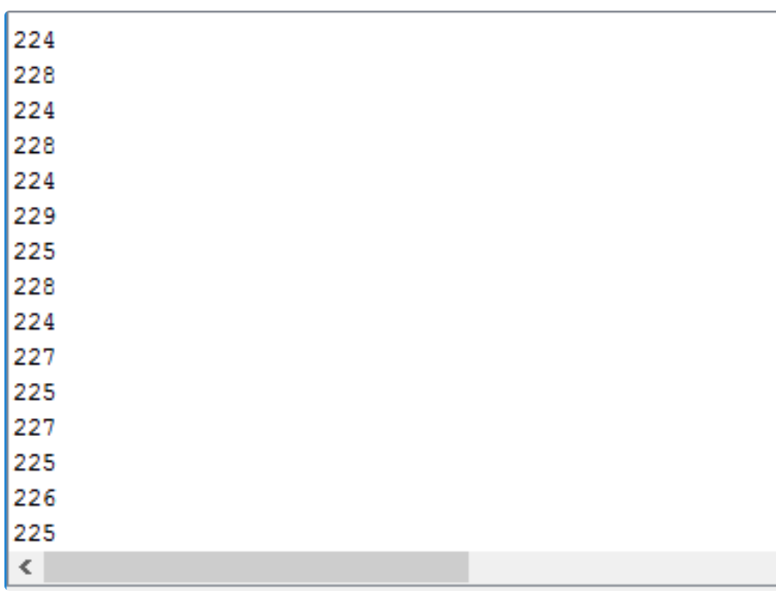

**5.3 FLOW CHART OF FIELD MONITORING ROBOT**

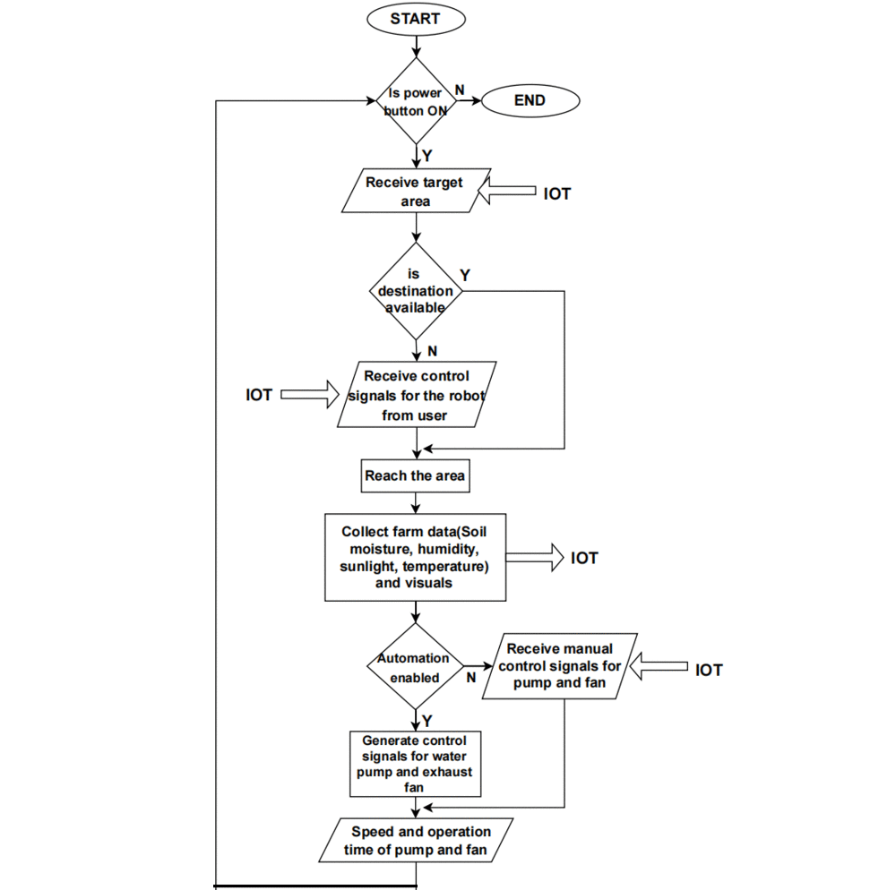

**5.4 FLOW CHART OF ROBOTIC ARM**

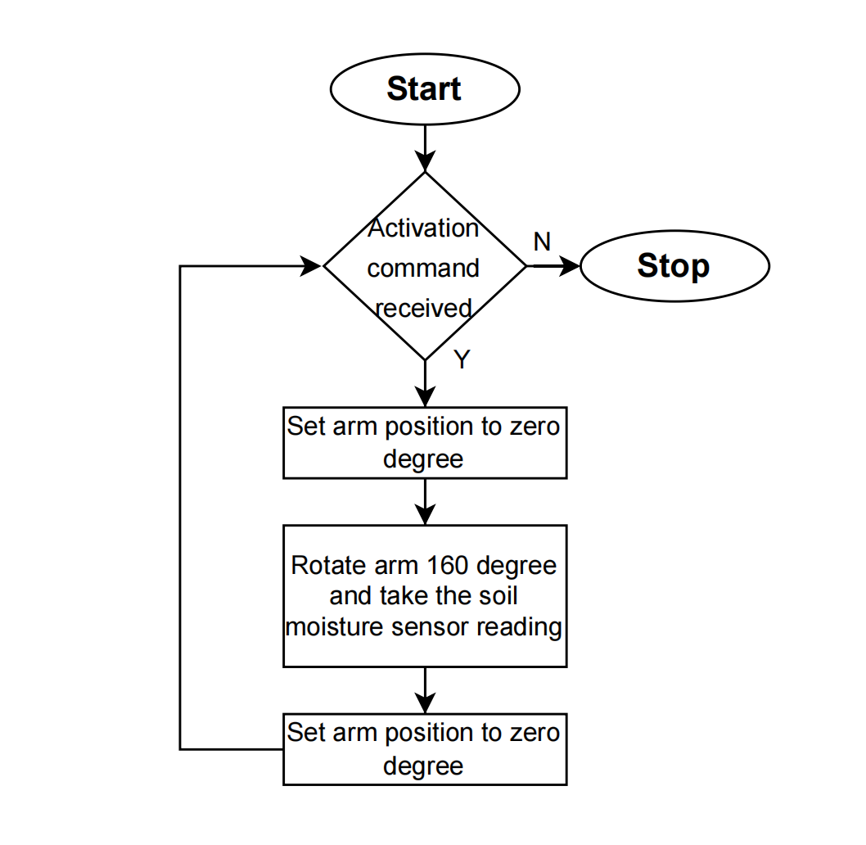

**CHAPTER 6**

**HARDWARE IMPLEMENTATION AND OUTPUTS**

**6.1 CHAPTER OVERVIEW**

This chapter comprises of the components that were implemented for the successful completion of the hardware part of the project and the obtained results and outputs.

**6.2 BATTERY**

Batteries are used to provide uninterrupted power supply to the load under varying conditions. A 12V lead acid battery is used for powering the inverter. It is a 7 Ah C20 rated battery and is sufficient enough to carry the designed load for 1 hr.

**6.3 VOLTAGE REGULATOR**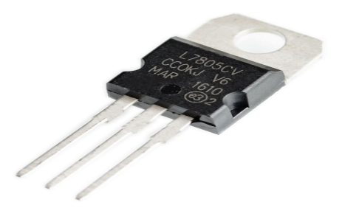

IC 7805 (Figure 6.1) is a 5V Voltage Regulator that restricts the output voltage to 5V output for various ranges of input voltage. It acts as an excellent component against input voltage fluctuations for circuits, and adds an additional safety to the circuitry. Here, the voltage regulator converts 12V to stable 5V DC output for the various components. *fig. 6.1 Voltage regulator.*

**6.4 POWER SUPPLY**

Power supply to various microcontrollers and sensor modules are provided from the 5V voltage regulator. Similarly power supply to the two servo motor is again provided from a separate 5V voltage regulator. The Cam module is powered by a separate 5V battery.

**6.5 PCB DESIGNING**

**6.5.1 INTRODUCTION**

A PCB is used to mechanically support and electrically connect electronic components using conductive pathways, tracks or etched from copper sheets. It is also referred to as PWB. A PCB populated with electronic components is PCA, also known as a PCBA. PCB is inexpensive, and can be highly reliable. They require much more layout effort and higher initial cost than either wire-wrapped or point-to-point constructed circuits, but are much cheaper and faster for high-volume production. One of the most discouraging things about making a hardware project is building PCB. Due to the improvements in printing technologies, it is now relatively easy to make inexpensive high-quality PCBs at home. PCB stands for Printed Circuit Board. It is of two types:

General purpose - It is already drilled and etched.

Special purpose - It requires a step by step process of making layout then etching and then drilling.

**6.5.2 PCB CONSTRUCTION**

The different processes that take place in the fabrication of a PCB are as follows: -

1. Layout designing

2. Transfer of pattern on copper board.

3. Drying

4. Etching

5. Tinning

6. Drilling

7. Soldering

8. Surface cleaning

9. Final inspection of PCB

**6.5.3 EQUIPMENTS REQUIRED**

The various tools and equipment required for construction of a PCB are given below: -

a) Solder kit consist of: -

i) Soldering iron.

ii) Soldering wire.

iii) Flux

b) Tweezers

c) Cutter

d) Multi-meter (Measuring instrument)

**6.5.4 PRECAUTIONS FOR PRACTICAL**

i. The quantity of soldering for each component on PCB should be adequate.

ii. The component fitted on the PCB should be tightly fit.

iii. Use ferric chloride safely.

iv. Add ferric chloride to the water, not water to the ferric chloride.

**6.6 CIRCUIT DIAGRAM**

The circuit diagram of both the Agriculture Monitoring Robot as well as that of On Field Controller Unit is shown below.

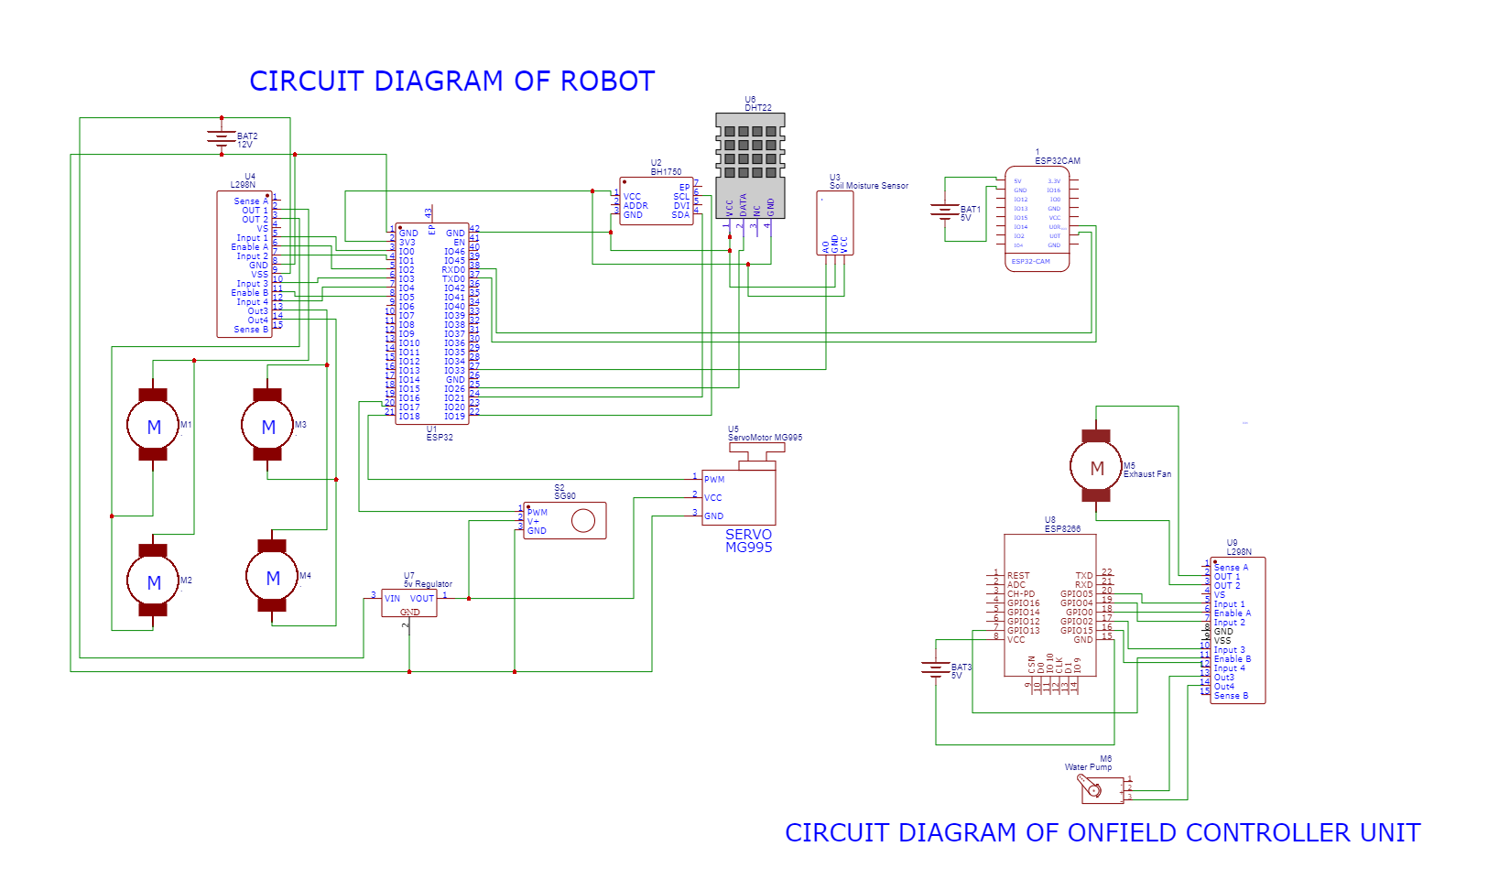

*fig. 6.2 Circuit diagram of the project.*

**6.7 RESULTS AND OUTPUT**

To test and verify the IoT based smart agriculture robotic system, we collected data under different conditions and the following results were obtained

**TABLE XI**

**RESULTS AND OUTPUT - TRIAL 1**

|  |  |  |  |  |
| --- | --- | --- | --- | --- |
| Trial 1 | | | | |
| Temperature(°C) | 29 ̊ C | 28 ̊ C | 28 ̊ C | 28 ̊ C |
| Humidity(in %) | 78% | 81% | 81% | 79% |
| Soil Moisture (in %) | 13% | 13% | 65% | 43% |

**TABLE XII**

**RESULTS AND OUTPUT - TRIAL 2**

|  |  |  |  |  |
| --- | --- | --- | --- | --- |
| Trial 2 | | | | |
| Temperature(°C) | 27 ̊ C | 27 ̊ C | 30 ̊ C | 30 ̊ C |
| Humidity(in %) | 90% | 77% | 76% | 76% |
| Soil Moisture (in %) | 0% | 0% | 42% | 99% |

**6.8 BLYNK INTERFACE**

The Blynk interface allows the user to view and interpret the data collected from the farm. It provides a wide variety of visualization tools for the accurate representation of data. The interface also allows the user to send commands or control signals to the robot as well as the on field controller unit. This is implemented using different types of buttons and sliders. The Blynk interface for the agriculture monitoring system is shown below.

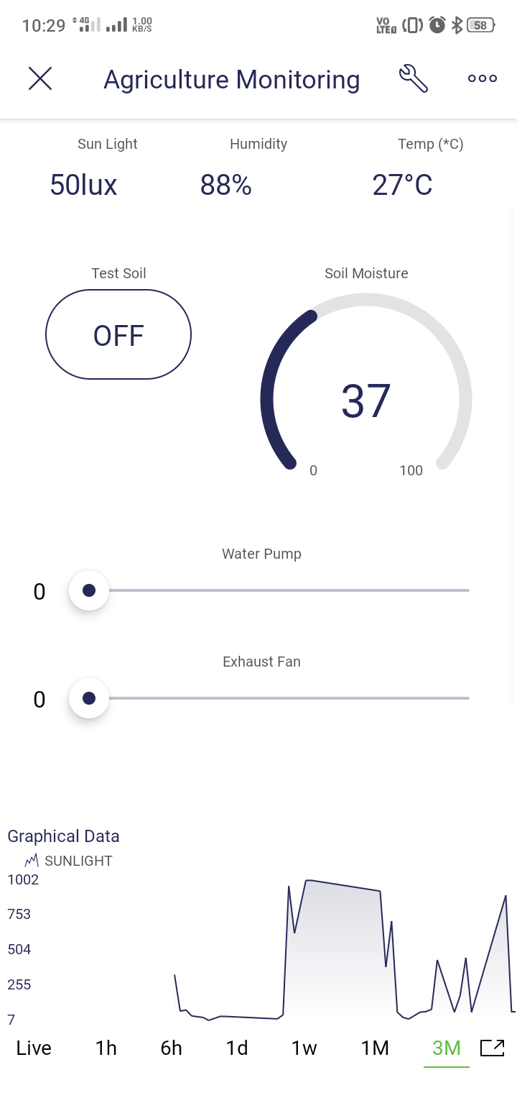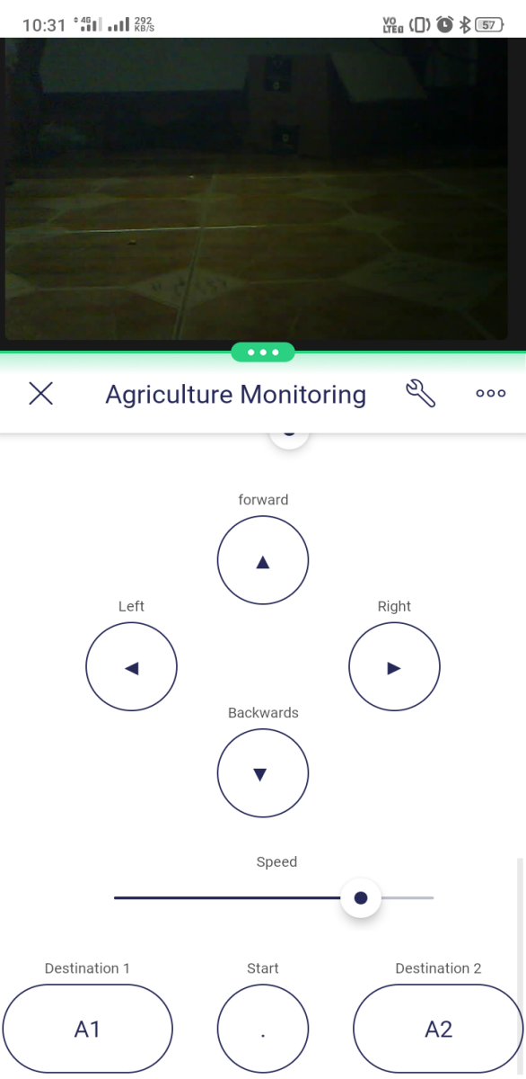

*Fig 6.3 Blynk interface for agriculture monitoring system*

**6.9 PATH PLANNING**

Path planning is also implemented which enables the robot to reach the target area on it’s own based on the destination provided by the user.The robot uses distance, speed and directions to formulate the path to reach the specified location from it’s starting location.It uses the same process to return to its initial starting position after performing monitoring in the area selected by the user.The aim of path planning is to make the robot more smart and efficient. It also makes the robot more user friendly.

Path planning allows the user to relocate the robot to a specified location in the farm simply by clicking on a button provided on the Blynk interface. In this project two separate areas are created for each of the selected crops. A base location is provided for the robot from which it can move to either area 1 or area 2 based on the command received from the user. The robot is aware of its current position by updating the position flag during program execution.

**CHAPTER 7**

**CROP SELECTION AND CONTROL OF FARM PARAMETERS**

**7.1 SELECTION OF CROPS**

For the demonstration of the project 2 crops with different requirements and growing conditions were selected. These crops are grown in two separate greenhouses. The greenhouse is provided with an irrigation system and exhaust fan for controlling soil moisture, humidity and temperature inside the greenhouse. The requirements and optimum growing conditions for each crop was studied and the following data was obtained. Automatic control of irrigation system and exhaust fan for each crop was formulated based on this data set [9].

**TABLE XIII**

**SELECTION OF CROPS**

|  |  |  |
| --- | --- | --- |
| PARAMETER | CORIANDER | RED SPINACH |
| Temperature Range | 17-25 ̊ C | 25-30 ̊ C |
| Moisture level | 45-55% | 30-50% |
| Sunlight | 6-8 hrs, 25000-40000 lux | 7-8 hrs, 8000-28000 lux |
| pH | 6.2 to 6.8 | 7.5 to 9.5 |
| Season | October to november | Throughout the year |

**7.2 IRRIGATION CONTROL**

The irrigation level is controlled by varying the operation speed of the water pump.The operation speed is selected either manually by the user or automatically based on the moisture percent in the soil. Controlled irrigation based on soil moisture can definitely save both electricity and water [8]. In addition it also provides optimum growing conditions for the crops thus the yield also gets enhanced [3]. The operation time and speed of the water pump is selected such that the soil moisture for each crop is always maintained within optimum ranges specified in the above mentioned data set.

**TABLE XIV**

**IRRIGATION CONTROL**

|  |  |  |
| --- | --- | --- |
| SOIL MOISTURE VALUE | SPEED (0-5 levels) | OPERATING TIME |
| <10% | 5 | 15 min |
| 10-15% | 4 | 10 min |
| 15-30% | 3 | 7 min |
| 30-40% | 2 | 5min |
| 40-60% | 1 | 3 min |
| >60% | 0 | - |

**7.3 EXHAUST CONTROL**

Humidity and temperature inside the greenhouse also affects the crop growth as well as its overall yield. Therefore these values need to be maintained within optimum ranges for each crop. The humidity and temperature levels in the greenhouse is also controlled by varying the speed of the exhaust fan [10].Based on the temperature and humidity values sensed by the robot the operation of the exhaust fan can be controlled either manually or automatically. The operation time and speed of the exhaust fan is selected such that the temperature and humidity for each crop is always maintained within the optimum ranges specified in the above mentioned data set [2].

**TABLE XV**

**EXHAUST CONTROL**

|  |  |  |
| --- | --- | --- |
| HUMIDITY & TEMP VALUE | SPEED (0-5 levels) | OPERATING TIME |
| >90% | 5 | 10 min |
| 90-85% | 4 | 8 min |
| 85-80% | 3 | 6 min |
| 80-78% | 2 | 4 min |
| 78-70% | 1 | 2 min |
| <70% | 0 | - |
| temp > 34 ̊ C | 5 | 10 min |

**CHAPTER 8**

**CONCLUSIONS**

Technology is progressing towards a world where everything is connected and IoT is there to achieve this. This promise is being realized by several industries who have moved into automating and interconnecting themselves with the help of IoT. This gives the users opportunities for better data analysis and provides guidance into faster and more efficient industries.

The project utilizes the features of IoT and aims at implementing this to the agricultural process of farming with the hopes of resolving some of the issues in this area.Based on above mentioned system setup, different level of soil moisture and temperature value were sensed and based on predefined threshold value of soil moisture and temperature, ESP32 microcontroller controls the high voltage farming equipments without human intervention. In the absence of human beings in the agriculture field, this system provides continuous field monitoring and triggers the appropriate events according to the requirement. It reduces the human effort and cost of farming to a certain extent.

This project also aims to minimize the labor costs and valuable investments of farmers and help the farmers save time.Though there are some limitations with the project, it is still a big leap into getting a more aspiring connected future.Agricultural technologies are being modernized and day by day farmers are opting newer technologies and methods to cultivate crops.Similarly, the project would help the farmers to monitor and control the entire farming process which would cause an overall increase in the yield of crop production.Also the system sends the environmental parameters values to the cloud from the field in real time through wireless communication in every certain time interval. These values can be used for future analysis and can be considered for more parameters to be monitored like biotic factors such as fungi, monera etc. for better growth of the crop.

**CHAPTER 9**

**SCOPE FOR FUTURE**

The Internet of Things (IOT) is reconstructing the agri-business which enables farmers to deal with challenges in the field more effectively. IoT solutions are focused on helping farmers close the supply demand gap, by ensuring high yields, profitability, and protection of the environment. The approach of using IoT technology to ensure optimum application of resources to achieve high crop yields and reduce operational costs is called precision agriculture. IoT in agriculture technologies comprise specialized equipment, wireless connectivity, software and IT services.Smart farming based on IoT technologies enables growers and farmers to reduce waste and enhance productivity ranging from the quantity of fertilizer utilized to the number of journeys the farm vehicles have made, and enabling efficient utilization of resources such as water, electricity, etc. IoT smart farming solutions is a system that is built for monitoring the crop field with the help of sensors (light, humidity, temperature, soil moisture, crop health, etc.) and automating the irrigation system. The farmers can monitor the field conditions from anywhere. They can also select between manual and automated options for taking necessary actions based on this data. For example, if the soil moisture level decreases, the farmer can deploy sensors to start the irrigation. Smart farming is highly efficient when compared with the conventional approach.As a result of the declining agricultural workforce, adoption of internet connectivity solutions in farming practices has been triggered, to reduce the need for manual labor.

IoT has the potential to transform agriculture in many aspects and these are the main ones.

* **Data collected by smart agriculture sensors**: in this approach of farm management, a key component are sensors, control systems, robotics, autonomous vehicles, automated hardware, variable rate technology, motion detectors, button cameras, and wearable devices. This data can be used to track the state of the business in general as well as staff performance, equipment efficiency. The ability to foresee the output of production allows us to plan for better product distribution.
* **Agricultural Drones:** Ground-based and aerial-based drones are being used in agriculture in order to enhance various agricultural practices: crop health assessment, irrigation, crop monitoring, crop spraying, planting, and soil and field analysis.
* **Livestock tracking and geofencing:** Farm owners can utilize wireless IoT applications to collect data regarding the location, well-being, and health of their cattle. This information helps to prevent the spread of disease and also lowers labor costs.
* **Smart Greenhouses**: A smart greenhouse designed with the help of IoT intelligently monitors as well as controls the climate, eliminating the need for manual intervention.
* **Predictive analytics for smart farming:** Crop prediction plays a key role, it helps the farmer to decide future plans regarding the production of the crop, its storage, marketing techniques and risk management. To predict production rate of the crop artificial network use information collected by sensors from the farm. This information includes parameters such as soil, temperature, pressure, rainfall, and humidity. The farmers can get accurate soil data either by the dashboard or a customized mobile application.

Farmers have started to realize that the IoT is a driving force for increasing agricultural production in a cost-effective way.

**REFERENCES**

1. Md Shadman Tajwar Haque;Khaza Abdur Rouf;Zobair Ahmed Khan;Al Emran;Md. Saniat Rahman Zishan, “ **Design and Implementation of an IoT based Automated Agricultural Monitoring and Control System,**” 2019 *International Conference on Robotics,Electrical and Signal Processing Techniques*, vol. 21, no. 3, pp. 567– 577, May 2019*.*
2. Liu Dan;Cao Xin;Huang Chongwei;Ji Liangliang, “**Intelligent Agriculture Greenhouse Environment Monitoring System Based on IOT Technology, ”** 2015 *International Conference on Intelligent Transportation, Big Data and Smart City,* vol. 54, no. 3, pp. 763–770, May 2015.
3. Chen, Qi, Gui, Gu, Ma, Zeng, et al., "**A model-based real-time decision support system for irrigation scheduling to improve water productivity,** " *Agronomy*, vol. 9, no. 11, pp. 686, Oct. 2019, vol. 55, no. 6, pp. 2258–2267.
4. Mehedi Hasan;Kamrul Nazir Walli Uddin;Tasnuva Tasneem, “ **Smart Agriculture Robotic System Based on Internet of Things to Boost Crop Production,** ” 2021 *2nd International Conference on Robotics, Electrical and Signal Processing Techniques* (ICREST), Sep. 2021, pp. 1–6.
5. Ji-chun Zhao;Jun-feng Zhang;Yu Feng ;Jian-xin Guo ” **The study and application of the IOT technology in agriculture,** ” 2010 *3rd International Conference on Computer Science and Information Technology*, vol. 53, no. 1, pp. 199–205, Jan. 2010.
6. **IOT Based Agriculture Monitoring and Controlling System** A. Lakshmi;Y. Ravi Kumar;N. Sai Krishna;G. Manisha 2021 *6th International Conference on Communication and Electronics Systems* (ICCES), vol. 40, no. 1, pp. 96–104, Feb. 2021.
7. Md AshifuddinMondal ;Zeenat Rehena “ **IoT Based Intelligent Agriculture Field Monitoring System,** ” 2018 *8th International Conference on Cloud Computing, Data Science & Engineering*, June 2018, pp. 1369–1374.
8. N. Romano, "**Soil moisture at local scale: Measurements and simulations,**" J. Hydrol., vol. 516, pp. 6-20, Aug. 2014.
9. Yash Bhojwani;Rishab Singh;Rachana Reddy; Boominthan Perumal “**Crop Selection and IoT Based Monitoring System for Precision Agriculture,** ” 2020 *International Conference on Emerging Trends in Information Technology and Engineering* (ic-ETITE).
10. Nisar Ahmad;Ali Hussain;Ihsan Ullah;Bizzat Hussain Zaidi,” **IOT based Wireless Sensor Network for Precision Agriculture,** ” 2019 *7th International Electrical Engineering Congress,* Sep. 2019, pp. 477–482.
11. S. R. Prathibha;Anupama Hongal;M. P. Jyothi, “ **IOT Based Monitoring System in Smart Agriculture,** ” 2017 *International Conference on Recent Advances in Electronics and Communication Technology*, Sep. 2017, p. 6.
12. Tianchen Qiu;Hang Xiao;Pei Zhou, “ **Framework and case studies of intelligence monitoring platform in facility agriculture ecosystem,** ” 2013 *Second International Conference on Agro-Geoinformatics*, Apr. 2013, pp. 1685–1690.

**APPENDIX-I**

**TABLE-V**

**LIST OF COMPONENTS**

|  |  |
| --- | --- |
| 1. | ESP32 |
| 2. | ESP8266 |
| 3. | ESP32 Cam Board |
| 4. | Light sensor-BH1750 |
| 5. | Soil moisture sensor-XH-M214 |
| 6. | Temperature and humidity sensor-DHT22 |
| 7. | DC geared motor |
| 8. | Battery |
| 9. | Servo motor-SG90 |
| 10 | Servo motor-MG995 |
| 11 | IC voltage regulator |

**APPENDIX-II**

**ARDUINO PROGRAM FOR ESP32**

#define ENA 25

#define IN1 26

#define IN2 27

#define IN3 14

#define IN4 12

#define ENB 13

bool forward = 0;

bool backward = 0;

bool left = 0;

bool right = 0;

int Speed=0;

int power=0;

#include "WiFi.h"

#include <BH1750.h>

BH1750 lightMeter;

#include <Wire.h>

#include <SPI.h>

#include <ESP32Servo.h>

#include <analogWrite.h>

#include "DHT.h"

#define DHTPIN 23

#define DHTTYPE DHT22

DHT dht(DHTPIN, DHTTYPE);

#define BLYNK_TEMPLATE_ID "TMPLDaV3cZgL"

#define BLYNK_DEVICE_NAME "Agriculture Monitoring Robot"

#define BLYNK_AUTH_TOKEN "AGGuivP3VkoXP7UJk0oQTCV7eglHgUTk"

const int AirValue = 790;

const int WaterValue = 390;

const int SensorPin = 34;

int soilMoistureValue;

int soilmoisturepercent=0;

Servo servo1;

Servo servo2;

int pos;

int servo1Pin = 4;

int servo2Pin = 32;

int arm=0;

int a1=0;

int a2=0;

int a3=0;

int loc=0;

#define BLYNK_PRINT Serial

#include <WiFiClient.h>

#include <BlynkSimpleEsp32.h>

char auth[] = BLYNK_AUTH_TOKEN;

BlynkTimer timer;

const char* ssid = "Realme";

const char* pass = "qwerty123";

int pump,fan;

void sendSensor()

{

float h = dht.readHumidity();

float t = dht.readTemperature();

Blynk.virtualWrite(V3, h);

Blynk.virtualWrite(V2, t);

}

void sendSoil(){

soilMoistureValue = analogRead(SensorPin);

soilmoisturepercent = constrain ( map(soilMoistureValue, 1000, 4095, 100, 0), 0, 100);

Blynk.virtualWrite(V4,soilmoisturepercent);

}

void sendUptime(){

uint16_t lux = lightMeter.readLightLevel();

Blynk.virtualWrite(V1, lux);

}

BLYNK_WRITE(V12) {

Speed = param.asInt();

Serial.println(Speed);

}

BLYNK_WRITE(V6)

{

int pump = param.asInt();

Serial.println(pump);

}

BLYNK_WRITE(V7)

{

int fan = param.asInt();

Serial.println(fan);

}

BLYNK_WRITE(V0) {

power = param.asInt();

}

void setup() {

Serial.begin(9800);

pinMode(SensorPin,INPUT);

pinMode(IN1, OUTPUT);

pinMode(IN2, OUTPUT);

pinMode(IN3, OUTPUT);

pinMode(IN4, OUTPUT);

pinMode(ENA, OUTPUT);

pinMode(ENB, OUTPUT);

WiFi.mode(WIFI_STA);

WiFi.begin(ssid, pass);

Serial.print("Connecting to "); Serial.println(ssid);

uint8_t i = 0;

while (WiFi.status() != WL_CONNECTED)

{

Serial.print('.');

delay(500);

if ((++i % 16) == 0)

{

Serial.println(F(" still trying to connect"));

}

}

Serial.print(F("Connected. My IP address is: "));

Serial.println(WiFi.localIP());

Blynk.begin(auth, ssid, pass);

timer.setInterval(1000L, sendSensor);

timer.setInterval(1000L, sendUptime);

Wire.begin();

lightMeter.begin();

dht.begin();

ESP32PWM::allocateTimer(0);

ESP32PWM::allocateTimer(1);

ESP32PWM::allocateTimer(2);

ESP32PWM::allocateTimer(3);

servo1.setPeriodHertz(50);

servo1.attach(servo1Pin);

servo2.setPeriodHertz(50);

servo2.attach(servo2Pin);

servo1.write(95);

}

BLYNK_WRITE(V8) {

forward = param.asInt();

}

BLYNK_WRITE(V9) {

backward = param.asInt();

}

BLYNK_WRITE(V10) {

left = param.asInt();

}

BLYNK_WRITE(V11) {

right = param.asInt();

}

BLYNK_WRITE(V15){

a1=param.asInt();

if(a1==1)

{

loc=1;

Speed=170;

carforward();

delay(1700);

carturnright();

delay(600);

carforward();

delay(1250);

carStop();

carturnright();

delay(617);

carforward();

delay(750);

carStop();

}

}

BLYNK_WRITE(V16){

a2=param.asInt();

if(a2==1)

{

if(loc==1)

{

loc=2;

Speed=170;

carbackward();

delay(750);

carturnleft();

delay(650);

carforward();

delay(1440);

carturnright();

delay(590);

carforward();

delay(700);

carStop();

}

if (loc==0){

loc=2;

carforward();

delay(1700);

carturnright();

delay(590);

carforward();

delay(2500);

carturnright();

delay(590);

carforward();

delay(750);

carStop();

}

}

}

BLYNK_WRITE(V17){

int t;

a3=param.asInt();

if(a3==1)

{

if(loc==1)

t=1250;

if(loc==2)

t=2500;

Speed=170;

carbackward();

delay(750);

carturnleft();

delay(650);

carbackward();

delay(t);

carturnleft();

delay(650);

carbackward();

delay(1700);

carStop();

loc=0;

}

}

BLYNK_WRITE(V14) {

pos = param.asInt();

int i;

for(i=0;i<=pos;i+=3)

{

servo1.write(pos); // tell servo to go to position in variable 'pos'

delay(20);

}

}

BLYNK_WRITE(V13) {

arm = param.asInt();

if(arm==1)

{

int i;

servo2.write(0);

for(i=0;i<=180;i+=3)

{

servo2.write(i); // tell servo to go to position in variable 'pos'

delay(80);

}

delay(2000);

sendSoil();

delay(2000);

for(i=180;i>0;i-=3)

{

servo2.write(i);

delay(80);

}

servo2.write(0);

}

}

void smartcar() {

if (forward == 1) {

carforward();

Serial.println("carforward");

} else if (backward == 1) {

carbackward();

Serial.println("carbackward");

} else if (left == 1) {

carturnleft();

Serial.println("carfleft");

} else if (right == 1) {

carturnright();

Serial.println("carright");

} else if (forward == 0 && backward == 0 && left == 0 && right == 0) {

carStop();

Serial.println("carstop");

}

}

void carforward() {

analogWrite(ENA, Speed);

analogWrite(ENB, Speed);

digitalWrite(IN1, LOW);

digitalWrite(IN2, HIGH);

digitalWrite(IN3, HIGH);

digitalWrite(IN4, LOW);

}

void carbackward() {

analogWrite(ENA, Speed);

analogWrite(ENB, Speed);

digitalWrite(IN1, HIGH);

digitalWrite(IN2, LOW);

digitalWrite(IN3, LOW);

digitalWrite(IN4, HIGH);

}

void carturnleft() {

analogWrite(ENA, Speed);

analogWrite(ENB, Speed);

digitalWrite(IN1, HIGH);

digitalWrite(IN2, LOW);

digitalWrite(IN3, HIGH);

digitalWrite(IN4, LOW);

}

void carturnright() {

analogWrite(ENA, Speed);

analogWrite(ENB, Speed);

digitalWrite(IN1, LOW);

digitalWrite(IN2, HIGH);

digitalWrite(IN3, LOW);

digitalWrite(IN4, HIGH);

}

void carStop() {

digitalWrite(IN1, LOW);

digitalWrite(IN2, LOW);

digitalWrite(IN3, LOW);

digitalWrite(IN4, LOW);

}

void loop() {

Blynk.run();

if(power==1){

timer.run();

}

if(power==1){

smartcar();

}

delay(10);

}

**ARDUINO PROGRAM FOR ESP8266**

#define BLYNK_TEMPLATE_ID "TMPLDaV3cZgL"

#define BLYNK_DEVICE_NAME "Agriculture Monitoring Robot"

#define BLYNK_AUTH_TOKEN "AGGuivP3VkoXP7UJk0oQTCV7eglHgUTk"

int ENA = 5;

int IN1 = 4;

int IN2 = 0;

int ENB= 14;

int IN3= 12;

int IN4= 13;

int speed1 =0;

int speed2=0;

int hum=0;

int temp=0;

#define BLYNK_PRINT Serial

#include <ESP8266WiFi.h>

#include <BlynkSimpleEsp8266.h>

char auth[] = BLYNK_AUTH_TOKEN;

char ssid[] = "Realme";

char pass[] = "qwerty123";

int pump=0;

int fan=0;

BLYNK_WRITE(V6)

{

pump = param.asInt();

}

BLYNK_WRITE(V7)

{

fan = param.asInt();

}

BLYNK_WRITE(V3)

{

hum = param.asInt();

}

BLYNK_WRITE(V2)

{

temp = param.asInt();

}

void setup()

{

Serial.begin(9600);

delay(10);

Serial.println("Connecting to ");

Serial.println(ssid);

WiFi.begin(ssid, pass);

while (WiFi.status() != WL_CONNECTED)

{

delay(500);

Serial.print(".");

}

Serial.println("");

Serial.println("WiFi connected");

Blynk.begin(auth, ssid, pass);

pinMode(IN1,OUTPUT);

pinMode(IN2,OUTPUT);

pinMode(ENA,OUTPUT);

pinMode(IN3,OUTPUT);

pinMode(IN4,OUTPUT);

pinMode(ENB,OUTPUT);

digitalWrite(IN1, LOW);

digitalWrite(IN2, LOW);

digitalWrite(IN3, LOW);

digitalWrite(IN4, LOW);

delay(10);

}

void pumping()

{

if(pump>0)

{

if(pump==1){

speed1=200;

}

else if(pump==2){

speed1=210;}

else if(pump==3){

speed1=220;}

else if(pump==4){

speed1=230;}

else{

speed1=255;}

Serial.println(speed1);

analogWrite(ENA, speed1);

digitalWrite(IN1, HIGH);

digitalWrite(IN2, LOW);

}

else

{

digitalWrite(IN1, LOW);

digitalWrite(IN2, LOW);

}

}

void airFlow()

{

if(fan>0)

{

if(fan==1){

speed1=20;

}

else if(fan==2){

speed2=60;}

else if(fan==3){

speed2=100;}

else if(fan==4){

speed2=180;}

else{

speed2=255;}

Serial.println(speed2);

analogWrite(ENB, speed2);

digitalWrite(IN3, HIGH);

digitalWrite(IN4, LOW);

}

else

{

digitalWrite(IN3, LOW);

digitalWrite(IN4, LOW);

}

}

void loop()

{

Blynk.run();

airFlow();

pumping();

if(temp>40||hum>90)

{

analogWrite(ENB, 250);

digitalWrite(IN3, HIGH);

digitalWrite(IN4, LOW);

delay(5000);

digitalWrite(IN3, LOW);

digitalWrite(IN4, LOW);

}

}

**APPENDIX IⅠⅠ**

**CASE STUDIES**

Some implementation of IoT based Agriculture Monitoring System in different areas and fields are:

1. **Greenhouse Automation**

As the demand for a variety of fruits and vegetables is growing it becomes important to create ideal conditions for a particular type of plant to grow and flourish. IoT enabled greenhouses monitor their ambient condition and adjust to avoid any deviation.

1. **Remote Irrigation**

Remote Irrigation is the next step of monitoring. They control the irrigation depending upon the soil and ambient temperature and humidity. IoT enabled irrigation systems not only save water but also ensure that crops are provided with just the right quantity of water. In IoT enabled irrigation, the irrigation depends on the soil moisture rather than a prefixed or pre-determined interval based irrigation.

1. **Precision Farming**

Precision agriculture, and site-specific crop management (SSCM) is farming management concepts that focus on observing, measuring, and responding to crop variability both in the field and between fields. Researchers are working to develop an integrated decision support system (DSS) for farm management that maximizes returns on inputs while protecting resources. Thanks to technological advancements, precision agriculture is now possible for both small and large-scale agricultural businesses alike. However, this trend has its origins in the 1990s and is only now becoming widespread. Farmers were able to gather datum and steer equipment automatically when GPS satellites were first adopted. Sensors, aerial devices, stationary IoT solutions for precision agriculture, and so on, are among the technologies that allow farmers to gather more precise data.

**APPENDIX IV**

**PROTOYPE FOR DEMONSTRATION**

